# 2017 Observing Notes

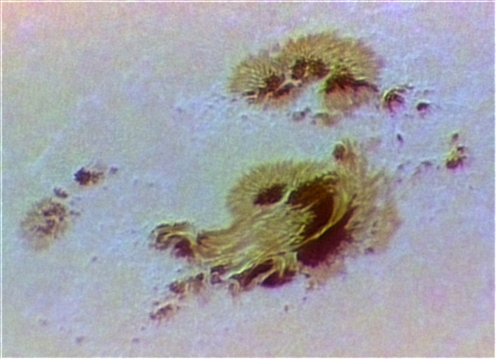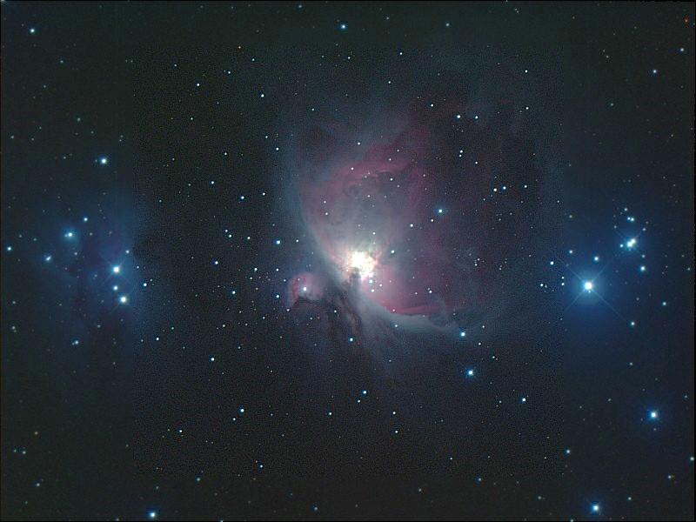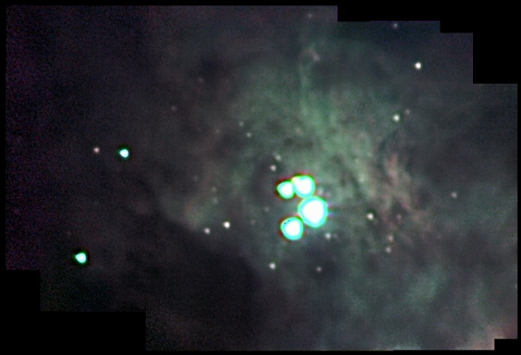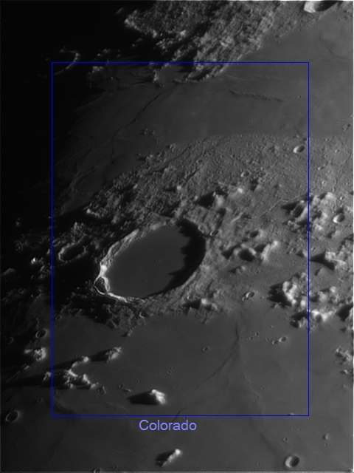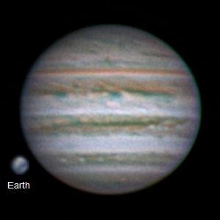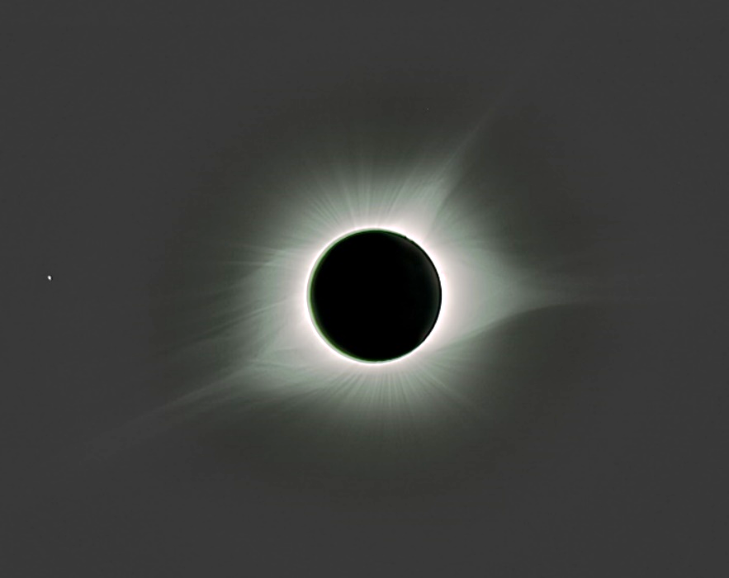

[2017 Observing Notes 1](#_Toc497199116)

[Year in Review 3](#_Toc497199117)

[January 4](#_Toc497199118)

[2017-Jan-17 (Jan-18 UT): M42 in 889nm CH4 4](#_Toc497199119)

[2017-Jan-18 (Jan-19 UT): M33 in 889nm CH4 and M42 in >685nm NIR and 889nm CH4 5](#_Toc497199120)

[2017-Jan-19 (Jan-20 UT): M33 in 380nm NUV 7](#_Toc497199121)

[February 8](#_Toc497199122)

[2017-Feb-20 (Feb-21 UT): M42 RGB 8](#_Toc497199123)

[March 9](#_Toc497199124)

[Spring 2017 Planning 9](#_Toc497199125)

[2017-Mar-15 (Mar-15&16 UT): Venus, M42 and NGC2392 Video 10](#_Toc497199126)

[April 13](#_Toc497199127)

[2017-Apr-12 (Apr-13 UT): Jupiter, Io, Europa and Ganymede 13](#_Toc497199128)

[2017-Apr-13 (Apr-14 UT): Jupiter 16](#_Toc497199129)

[May 18](#_Toc497199130)

[2017-May-04 (May-05 UT): Jupiter, Io, Europa and Moon 18](#_Toc497199131)

[2017-May-24 (May-25 UT): Jupiter, Io, Europa and Ganymede 23](#_Toc497199132)

[June 26](#_Toc497199133)

[2017-Jun-04 (Jun-05 UT): Jupiter, Io and Moon 26](#_Toc497199134)

[2017-Jun-14 (Jun-15 UT): Jupiter, Europa and Ganymede 28](#_Toc497199135)

[2017-Jun-15 (Jun-16 UT): Jupiter, Saturn 30](#_Toc497199136)

[July 32](#_Toc497199137)

[Summer 2017 Planning 32](#_Toc497199138)

[August 33](#_Toc497199139)

[2017-Aug-01 (Aug-02 UT): Moon and Saturn 33](#_Toc497199140)

[2017-Aug-18 (Aug-18 UT): Sun Imaging Tests 38](#_Toc497199141)

[2017-Aug-21 (Aug-21 UT): Eclipse in Alliance, Nebraska! 39](#_Toc497199142)

[2017-Aug-28 (Aug-29 UT): Saturn Video 42](#_Toc497199143)

[September 45](#_Toc497199144)

[2017-Sep-06 (Sep-06 UT): Sun – AR 12673 45](#_Toc497199145)

[October 46](#_Toc497199146)

[2017-Oct-07 (Oct-08 UT): Epsilon Lyrae, Lam Aqr 46](#_Toc497199147)

[Fall 2017 Planning 47](#_Toc497199148)

[2017-Oct-10 (Oct-11 UT): Double Stars, Neptune and Triton 49](#_Toc497199149)

[2017-Oct-14 (Oct-15 UT): Veil Nebula, M31 Wide-Field 52](#_Toc497199150)

[2017-Oct-15 (Oct-16 UT): Veil Nebula Wide-Field 53](#_Toc497199151)

[2017-Oct-17 (Oct-18 UT): Veil Nebula - Wide-Field, 380NUV 54](#_Toc497199152)

[2017-Oct-18 (Oct-19 UT): Neptune 55](#_Toc497199153)

[2017-Oct-21 (Oct-22 UT): IC1396 – Elephant Trunk Nebula 58](#_Toc497199154)

[2017-Oct-23 (Oct-24 UT): Veil Nebula 59](#_Toc497199155)

[2017-Oct-25 (Oct-26 UT): IC1396 – Elephant Trunk Nebula 60](#_Toc497199156)

[2017-Oct-28 (Oct-29 UT): NGC7822 61](#_Toc497199157)

[References 63](#_Toc497199158)

## Year in Review

This year had three main focuses: high resolution solar system imaging, multi-spectral deep sky imaging, and the total eclipse “expedition” to Alliance, Nebraska. The biggest single campaign in solar system imaging included seven nights of **Jupiter** observations. The intention was to capture sufficiently detailed images on multiple nights for similar longitudes. This would allow drift measurements over a wide range of longitudes because over shorter revisit times features would be more likely to maintain coherence. The analysis of the Jupiter observations – along with contemporaneous Galilean Moon observations – are included in *Jupiter\_Report.docx*.

Three nights of **Saturn** observations were conducted during the summer. The hope was to get very high-resolution imagery to track the longitudes of vertices’ of the north polar hexagon. Unfortunately, while Saturn’s tilt is most favorable to viewing the north polar region, it is also at it’s southernmost point on the ecliptic. Hence, seeing was degraded due to the large airmass. Mapping and other analyses of the Saturn campaign has yet to be completed (12/8/2017).

Efforts were made on to resolve features on **Uranus** (one night) and **Neptune** (three nights). These efforts focused on using the relatively high contrast available in the NIR, particularly the >685nm filter. Uranus disk was cleanly resolved, but any structure, even banding, is questionable. Likewise, Neptune’s disk was resolved, but no features were unequivocally identified. In particularly, I was trying to capture a large equatorial storm that was visible in slightly larger telescopes than mine. Finding Neptune continue to be a challenge due to it’s faintness and the lack of a go-to telescope. However, I did manage to get efficient at using a spiral search pattern.

Other high-resolution campaigns included a few regional observations of the Moon, a large solar active region, coverage of a few summer double stars, Venus (with an attempt at night-side thermal observations), the Eskimo Nebula, and the Orion Nebula.

Starting in the winter I closed out the moderate resolution, multiband observations of M42 and M33. Then in the fall I began wide field observations of several late summer and fall galactic nebulae and M31. I learned something important: Ar III emission is visible in the NIR >807nm filter. I had unambiguous detection and the spatial coincidence with O III emission, which has a similar ionization potential, was the smoking gun. I also explored the capabilities of PyNeb, in particular, ion abundance.

## January

### 2017-Jan-17 (Jan-18 UT): M42 in 889nm CH4

Last Updated 1/23/2017

TBD

|  |  |
| --- | --- |
| F:\Astronomy\Projects\Nebulae-Diffuse\M42 - Orion Nebula\Imaging Data\20170118UT-430mm\M42-20170118UT-889CH4a-sum02h47m30s-Artifact-Flattened-Log-HalfSize.jpg | F:\Astronomy\Projects\Nebulae-Diffuse\M42 - Orion Nebula\Imaging Data\20170118UT-430mm\M42-201XXXXXUT-889CH4-sum05h45m00s-Artifact-Flattened-Log-HalfSize.jpg |
| M42-20170118UT-889CH4a-sum02h47m30s-Artifact-Flattened-Log-HalfSize.jpg | M42-201XXXXXUT-889CH4-sum05h45m00s-Artifact-Flattened-Log-HalfSize.jpg |
| F:\Astronomy\Projects\Nebulae-Diffuse\M42 - Orion Nebula\Imaging Data\20170118UT-430mm\M42-201X-RGB-TestNIR-HalfSize.jpg |  |
| M42-201X-RGB-TestNIR-HalfSize.jpg |  |

**Data Disposition:** Raw data are zipped and on the 2TB archive drive. Processed data are under the Projects directory on the Astronomy thumb drive.

### 2017-Jan-18 (Jan-19 UT): M33 in 889nm CH4 and M42 in >685nm NIR and 889nm CH4

Last Updated 1/23/2017

TBD

|  |  |
| --- | --- |
| F:\Astronomy\Projects\Galaxies\M33\Imaging Data\20170119UT\M33-20170119UT-889CH4a-sum01h22m30s-Flattened-Lin-HalfSize.jpg | F:\Astronomy\Projects\Galaxies\M33\Imaging Data\20170119UT\M33-201XXXXXUT-889CH4-sum03h02m15s-WCS-Artifacts-Lin-HalfSize.jpg |
| M33-20170119UT-889CH4a-sum01h22m30s-Flattened-Lin-HalfSize.jpg | M33-201XXXXXUT-889CH4-sum03h02m15s-WCS-Artifacts-Lin-HalfSize.jpg |

|  |  |
| --- | --- |
| F:\Astronomy\Projects\Nebulae-Diffuse\M42 - Orion Nebula\Imaging Data\20170119UT-430mm\M42-20170119UT-685NIR-sum29m36s-Flattened-Log-HalfSize.jpg | F:\Astronomy\Projects\Nebulae-Diffuse\M42 - Orion Nebula\Imaging Data\20170119UT-430mm\M42-201XXXXXUT-685NIR-sum34m43s-Flattened-Log-HalfSize.jpg |
| M42-20170119UT-685NIR-sum29m36s-Flattened-Log-HalfSize.jpg | M42-201XXXXXUT-685NIR-sum34m43s-Flattened-Log-HalfSize.jpg |
| F:\Astronomy\Projects\Nebulae-Diffuse\M42 - Orion Nebula\Imaging Data\20170119UT-430mm\M42-20170119UT-889CH4a-sum01h55m-Flattened-Log-HalfSize.jpg | F:\Astronomy\Projects\Nebulae-Diffuse\M42 - Orion Nebula\Imaging Data\20170119UT-430mm\M42-201XXXXXUT-889CH4-sum07h40m-Flattened-Log-HalfSize.jpg |
| M42-20170119UT-889CH4a-sum01h55m-Flattened-Log-HalfSize.jpg | M42-201XXXXXUT-889CH4-sum07h40m-Flattened-Log-HalfSize.jpg |

**Data Disposition:** TBD.

### 2017-Jan-19 (Jan-20 UT): M33 in 380nm NUV

Last Updated 1/23/2017

TBD

|  |  |
| --- | --- |
| F:\Astronomy\Projects\Galaxies\M33\Imaging Data\20170120UT\M33-20170120UT-380NUV-sum01h23m-Flattened-Lin-HalfSize.jpg | F:\Astronomy\Projects\Galaxies\M33\Imaging Data\20170120UT\M33-201XXXXXUT-380NUV-sum6h55m30s-Flattened-WCS-Smoothed-Lin-HalfSize.jpg |
| M33-20170120UT-380NUV-sum01h23m-Flattened-Lin-HalfSize.jpg | M33-201XXXXXUT-380NUV-sum6h55m30s-Flattened-WCS-Smoothed-Lin-HalfSize.jpg |

**Data Disposition:** Raw data zipped on Astronomy laptop ready to move to 2TB archive drive. Processed data resides on the Astrothumb2 thumb drive.

## February

### 2017-Feb-20 (Feb-21 UT): M42 RGB

Last Updated 1/23/2017

TBD

|  |  |
| --- | --- |
| F:\Astronomy\Projects\Nebulae-Diffuse\M42 - Orion Nebula\Imaging Data\20170221UT-430mm\M42-20170221UT-650RED-sum0h55m-Artifacts-Flattened-Log-HalfSize.jpg | F:\Astronomy\Projects\Nebulae-Diffuse\M42 - Orion Nebula\Imaging Data\20170221UT-430mm\M42-20170221UT-550GRN-sum0h30m-Flattened-Log-HalfSize.jpg |
| M42-20170221UT-650RED-sum0h55m-Artifacts-Flattened-Log-HalfSize.jpg | M42-20170221UT-550GRN-sum0h30m-Flattened-Log-HalfSize.jpg |
| F:\Astronomy\Projects\Nebulae-Diffuse\M42 - Orion Nebula\Imaging Data\20170221UT-430mm\M42-20170221UT-450BLU-sum0h30m-Flattened-Log-HalfSize.jpg | F:\Astronomy\Projects\Nebulae-Diffuse\M42 - Orion Nebula\Imaging Data\20170221UT-430mm\M42-20170221UT-LRGB-HalfSize-Stretched-Sat150pct-Wavelets1x5Maskedt.jpg |
| M42-20170221UT-450BLU-sum0h30m-Flattened-Log-HalfSize.jpg | M42-20170221UT-LRGB-HalfSize-Stretched-Sat150pct-Wavelets1x5Maskedt.jpg |

**Data Disposition:** Raw data zipped on Astronomy laptop ready to move to 2TB archive drive. Processed data resides on the Astrothumb2 thumb drive. VERIFY MOVED TO 2B DRIVE.

## March

### Spring 2017 Planning

Last Updated 1/23/2017

* Observations
  + Spectra
    - Venus
    - Eskimo
    - Jupiter
    - 3C273
  + Video
    - Venus
    - Mars
    - Uranus
    - M42
    - Eskimo
    - Jupiter
    - Sirius (other double stars?)
  + Imaging
    - M81
    - M101

### 2017-Mar-15 (Mar-15&16 UT): Venus, M42 and NGC2392 Video

Last Updated 3/16/2017

This was the first set of imaging observations since reconfiguring the telescope to the C8-135mm lens set up from the TKE130 set up. However, I did do a visual observation with Nathan a couple of weeks earlier when we looked at Venus, Mars and the Moon.

Venus

|  |  |
| --- | --- |
| F:\Astronomy\Projects\Planets\Venus\Imaging Data\20170315UT\2017-03-16-0041_2-Venus_807NIR-Stack500-Wwavelets1x5+2x10+3x5+Contrast80pct.jpg | F:\Astronomy\Projects\Planets\Venus\Imaging Data\20170315UT\Venus-20170315UT-889CH4-LongStack-Flattened-Wavelets-Cropped.jpg |
| 2017-03-16-0041\_2-Venus\_807NIR-Stack500-Wwavelets1x5+2x10+3x5+Contrast80pct.jpg | Venus-20170315UT-889CH4-LongStack-Flattened-Wavelets-Cropped.jpg |

The attempt to image Venus’s night-side surface was not successful. This is due, I believe, to the terrestrial sky brightness in the 889nm filter band more than to reduced thermal emission from Venus in this band. It would probably be worthwhile to obtain a 1.0μm filter for the next attempt. Alternatively, perhaps a filter at approximately 970nm would be useful also as a “window” filter to compare to 889nm methane images of outer planets.

M42

|  |  |
| --- | --- |
| F:\Astronomy\Projects\Nebulae-Diffuse\M42 - Orion Nebula\Imaging Data\20170316UT\M42-20170316UT-650RED-Mosaic-Gam70pct.jpg | F:\Astronomy\Projects\Nebulae-Diffuse\M42 - Orion Nebula\Imaging Data\20170316UT\M42-20170316UT-550GRN-Mosaic-Gam70pct.jpg |
| M42-20170316UT-650RED-Mosaic-Gam70pct.jpg | M42-20170316UT-550GRN-Mosaic-Gam70pct.jpg |
| F:\Astronomy\Projects\Nebulae-Diffuse\M42 - Orion Nebula\Imaging Data\20170316UT\M42-20170316UT-450BLU-Mosaic-Gam70pct.jpg | F:\Astronomy\Projects\Nebulae-Diffuse\M42 - Orion Nebula\Imaging Data\20170316UT\M42-20170316UT-550CLR-Mosaic-Gam70pct.jpg |
| M42-20170316UT-450BLU-Mosaic-Gam70pct.jpg | M42-20170316UT-550CLR-Mosaic-Gam70pct.jpg |
| F:\Astronomy\Projects\Nebulae-Diffuse\M42 - Orion Nebula\Imaging Data\20170316UT\M42-20170316UT-X50-LRGB-Wavelets-ColBal-Gam70pct.jpg |  |
| M42-20170316UT-X50-LRGB-Wavelets-ColBal-Gam70pct.jpg |  |

Attempts to navigate these images using PinPoint astrometry in MaximDL failed. In addition, attempts to manually navigate these images in Aladin failed. In both cases, this is likely due to the very large saturated images of the Trapezium stars. Some sort of alternative, even more manual approach – probably iterative – must be tried. It would be terrific to have this navigation completed so that catalog info could be overlaid, in particular HH and proplyd data.

NGC2392

|  |  |
| --- | --- |
| F:\Astronomy\Projects\Nebulae-Planetary\NGC2392\Imaging Data\20170316UT\2017-03-16-0344_2-NGC2392_550CLR_V1-Stack452-Wavelets2x2+3x4+4x2-Avg-Gam2-Stretch20-255-Wavelets.jpg | F:\Astronomy\Projects\Nebulae-Planetary\NGC2392\Imaging Data\20170316UT\2017-03-16-0413_2-NGC2392_550CLR_V2-Stack151-Wavelets2x3+3x6+4x3-Stretch10-128.jpg |
| 2017-03-16-0344\_2-NGC2392\_550CLR\_V1-Stack452-Wavelets2x2+3x4+4x2-Avg-Gam2-Stretch20-255-Wavelets.jpg | 2017-03-16-0413\_2-NGC2392\_550CLR\_V2-Stack151-Wavelets2x3+3x6+4x3-Stretch10-128.jpg |
| F:\Astronomy\Projects\Nebulae-Planetary\NGC2392\Imaging Data\20170316UT\2017-03-16-0344_2-NGC2392_550CLR_VX-Hybrid-Stack653-WaveletsV2.jpg |  |
| 2017-03-16-0344\_2-NGC2392\_550CLR\_VX-Hybrid-Stack653-WaveletsV2.jpg |  |

## April

### 2017-Apr-12 (Apr-13 UT): Jupiter, Io, Europa and Ganymede

Last Updated 4/20/2017

Very good seeing. Very transparent sky. Linear gamma on 889CH4!

|  |  |
| --- | --- |
| F:\Astronomy\Projects\Planets\Jupiter\Imaging Data\20170413UT\2017-04-13-0410_3-Hill-Jupiter-RGB-Wavelets.jpg | F:\Astronomy\Projects\Planets\Jupiter\Imaging Data\20170413UT\2017-04-13-0414_6-Hill-Jupiter-RED-685-807-Wavelets.jpg |
| 2017-04-13-0410\_3-Hill-Jupiter-RGB-Wavelets.jpg | 2017-04-13-0414\_6-Hill-Jupiter-RED-685-807-Wavelets.jpg |
| F:\Astronomy\Projects\Planets\Jupiter\Imaging Data\20170413UT\2017-04-13-0415_8-Hill-Jupiter-889-GRN-BLU-Wavelets.jpg |  |
| 2017-04-13-0415\_8-Hill-Jupiter-889-GRN-BLU-Wavelets.jpg |  |

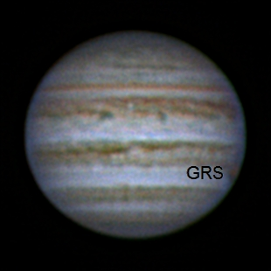

2017-04-13-0410\_3-Hill-Jupiter-RGB-Wavelets-Annotated.jpg

|  |  |  |
| --- | --- | --- |
| F:\Astronomy\Projects\Planets\Jupiter\Imaging Data\20170413UT\2017-04-13-0448_8-Io+Europa_685-IoStack60-Wavelets1x15+2x5-IoCrop-2x.jpg | F:\Astronomy\Projects\Planets\Jupiter\Imaging Data\20170413UT\2017-04-13-0448_8-Io+Europa_685-EuropaStack60-Wavelets1x15+2x5-EuropaCrop-2x.jpg | F:\Astronomy\Projects\Planets\Jupiter\Imaging Data\20170413UT\2017-04-13-0453_3-Ganymede_685-Stack200-Wavelets1x30+2x15-Crop-2x.jpg |
| 2017-04-13-0448\_8-Io+Europa\_685-IoStack60-Wavelets1x15+2x5-IoCrop-2x.jpg | 2017-04-13-0448\_8-Io+Europa\_685-EuropaStack60-Wavelets1x15+2x5-EuropaCrop-2x.jpg | 2017-04-13-0453\_3-Ganymede\_685-Stack200-Wavelets1x30+2x15-Crop-2x.jpg |

QuickMoonsRSSAnalysis.xlsx



Two videos were taken, one of Io and Europa together and the other of Ganymede. Using the relative positions of Io and Europa the astrometrically determined plate scale was found to be 0.1734 arcsec-pixel-1.

Assuming the observed size of the satellites to represent the actual size added in quadrature with a Gaussian representing system resolution, one can compute that resolution. In the case here, the observed size of Ganymede is smaller than the expected size (if FWHM is a good representation of size!) and so is not considered in the calculations. Using only Io and Europa, we find the system resolution to be 0.694±0.040 arcsec (95% confidence). This is consistent with the visual appearance of the Jupiter images in the same spectral band. Note that the estimated resolution determined independent of the plate scale not very consistent at 1.090 arcsec.

**Data Disposition:** Raw data are zipped and on the 2TB archive drive. Processed data are under the Projects directory on the Astronomy thumb drive.

### 2017-Apr-13 (Apr-14 UT): Jupiter

Last Updated 4/20/2017

Moderate seeing. **High and variable clouds**. Linear gamma on 889CH4!

|  |  |
| --- | --- |
| F:\Astronomy\Projects\Planets\Jupiter\Imaging Data\20170414UT\2017-04-14-0402_8-Hill-Jupiter-RGB-Wavelets.jpg | F:\Astronomy\Projects\Planets\Jupiter\Imaging Data\20170414UT\2017-04-14-0406_5-Hill-Jupiter-807-685-RED-Wavelets.jpg |
| 2017-04-14-0402\_8-Hill-Jupiter-RGB-Wavelets.jpg | 2017-04-14-0406\_5-Hill-Jupiter-807-685-RED-Wavelets.jpg |
| F:\Astronomy\Projects\Planets\Jupiter\Imaging Data\20170414UT\2017-04-14-0413_1-Hill-Jupiter-889-GRN-NUV-Wavelets.jpg |  |
| 2017-04-14-0413\_1-Hill-Jupiter-889-GRN-NUV-Wavelets.jpg |  |

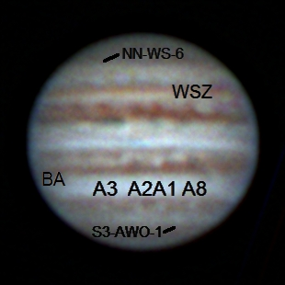

2017-04-14-0402\_8-Hill-Jupiter-RGB-Wavelets-Annotated.jpg

**Data Disposition:** Raw data are zipped and on the 2TB archive drive. Processed data are under the Projects directory on the Astronomy thumb drive.

## May

### 2017-May-04 (May-05 UT): Jupiter, Io, Europa and Moon

Last Updated 4/20/2017

Very steady seeing (4.5/5!?) and very good transparency. Linear gamma on CH4 and NUV.

|  |  |
| --- | --- |
| F:\Astronomy\Projects\Planets\Jupiter\Imaging Data\20170505UT\2017-05-05-0336_1-Hill-Jupiter-RGB-WhtBal-Stretch-0to192-Wavelets.png | F:\Astronomy\Projects\Planets\Jupiter\Imaging Data\20170505UT\2017-05-05-0341_7-Hill-Jupiter-807-685-RED-WhtBal-Sat200pct-Wavelets.png |
| 2017-05-05-0336\_1-Hill-Jupiter-RGB-WhtBal-Stretch-0to192-Wavelets.png | 2017-05-05-0341\_7-Hill-Jupiter-807-685-RED-WhtBal-Sat200pct-Wavelets.png |
| F:\Astronomy\Projects\Planets\Jupiter\Imaging Data\20170505UT\2017-05-05-0351_2-Hill-Jupiter-889-GRN-NUV-ColBal-Wavelets.png | F:\Astronomy\Projects\Planets\Jupiter\Imaging Data\20170505UT\2017-05-05-0347_6-Hill-Jupiter-807-GRN-NUV-WhtBal-Wavelets.png |
| 2017-05-05-0351\_2-Hill-Jupiter-889-GRN-NUV-ColBal-Wavelets.png | 2017-05-05-0347\_6-Hill-Jupiter-807-GRN-NUV-WhtBal-Wavelets.png |

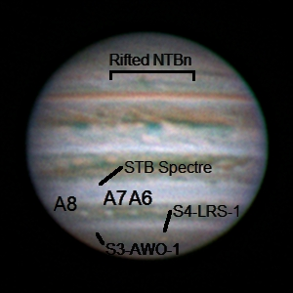

|  |  |  |  |
| --- | --- | --- | --- |
| F:\Astronomy\Projects\Planets\Jupiter\Imaging Data\20170505UT\2017-05-05-0348_2-Jupiter_685NIR_Full-IoAligned-Stack50-Wavelets1x10+2x5-Cropped-2x.jpg | F:\Astronomy\Projects\Planets\Jupiter\Imaging Data\20170505UT\2017-05-05-0347_3-Jupiter_685NIR_Full-IoAligned-Stack100-Stretch0to64-Wavelets1x10+2x5-Cropped-2x.jpg | F:\Astronomy\Projects\Planets\Jupiter\Imaging Data\20170505UT\2017-05-05-0348_2-Jupiter_685NIR_Full-EuropaAligned-Stack40-Wavelets1x10+2x5-Cropped-2x.jpg | F:\Astronomy\Projects\Planets\Jupiter\Imaging Data\20170505UT\2017-05-05-0347_3-Jupiter_685NIR_Full-EuropaAligned-Stack100-Stretch0to64-Wavelets1x10+2x5-Cropped-2x.jpg |
| 2017-05-05-0348\_2-Jupiter\_685NIR\_Full-IoAligned-Stack50-Wavelets1x10+2x5-Cropped-2x.jpg | 2017-05-05-0347\_3-Jupiter\_685NIR\_Full-IoAligned-Stack100-Stretch0to64-Wavelets1x10+2x5-Cropped-2x.jpg | 2017-05-05-0348\_2-Jupiter\_685NIR\_Full-EuropaAligned-Stack40-Wavelets1x10+2x5-Cropped-2x.jpg | 2017-05-05-0347\_3-Jupiter\_685NIR\_Full-EuropaAligned-Stack100-Stretch0to64-Wavelets1x10+2x5-Cropped-2x.jpg |

20170505T0347.3UT



20170505T0348.2UT



Two videos were taken, one at 0347.3UT and the other at 0348.2UT. The first one used very short exposures with a linear gamma. The other used much longer exposures. Using the relative positions of Io and Europa the astrometrically determined plate scale was found to be 0.1726±0.002 arcsec-pixel-1. This is very close to the previously determined 0.1734 arcsec-pixel-1 determined from 20170414UT (about a 0.46% difference).

The difference between the two videos is evident in the effective system resolution. For the short exposures at 0347.3UT the resolution is 0.580±0.040 arcsec (95% confidence). For the long exposures at 0348.2UT the resolution is 0.815±0.019 arcsec. Note that the estimated resolution determined independent of the plate scale pretty consistent at 0.860 and 0.728 arcsec.

**Data Disposition:** Raw data are zipped and on the 2TB archive drive. Processed data are under the Projects directory on the Astronomy thumb drive.

|  |  |
| --- | --- |
| F:\Astronomy\Projects\Moon\Imaging Data\20170505UT\2017-05-05-0410_6-Moon_685NIR-CraterCentered-Stack200-Wavelets1x15+2x10-Gamma1.3-HalfSize.jpg | F:\Astronomy\Projects\Moon\Imaging Data\20170505UT\2017-05-05-0412_7-Moon_685NIR-StraightWallAligned-Stack200-Wavelets1x15+2x10-HalfSize.jpg |
| 2017-05-05-0410\_6-Moon\_685NIR-CraterCentered-Stack200-Wavelets1x15+2x10-Gamma1.3-HalfSize.jpg | 2017-05-05-0412\_7-Moon\_685NIR-StraightWallAligned-Stack200-Wavelets1x15+2x10-HalfSize.jpg |
| F:\Astronomy\Projects\Moon\Imaging Data\20170505UT\2017-05-05-0410_6-Moon_685NIR-CraterCentered-Stack200-Wavelets1x15+2x10-Gamma1.3-HalfSize.jpg | F:\Astronomy\Projects\Moon\Imaging Data\20170505UT\2017-05-05-0412_7-Moon_685NIR-StraightWallAligned-Stack200-Wavelets1x15+2x10-HalfSize.jpg |
| 2017-05-05-0410\_6-Moon\_685NIR-CraterCentered-Stack200-Wavelets1x15+2x10-Gamma1.3-HalfSize.jpg | 2017-05-05-0412\_7-Moon\_685NIR-StraightWallAligned-Stack200-Wavelets1x15+2x10-HalfSize.jpg |

|  |  |
| --- | --- |
| F:\Astronomy\Projects\Moon\Imaging Data\20170505UT\2017-05-05-0415_3-Moon_685NIR-ClaviusAligned-Stack200-Wavelets1x15+2x10-Gamma1.3-HalfSize.jpg | F:\Astronomy\Projects\Moon\Imaging Data\20170505UT\2017-05-05-0419_7-Moon_685NIR-PlatoAligned-Stack200-Wavelets1x15+2x10-Gamma1.3-HalfSize.jpg |
| 2017-05-05-0415\_3-Moon\_685NIR-ClaviusAligned-Stack200-Wavelets1x15+2x10-Gamma1.3-HalfSize.jpg | 2017-05-05-0419\_7-Moon\_685NIR-PlatoAligned-Stack200-Wavelets1x15+2x10-Gamma1.3-HalfSize.jpg |

### 2017-May-24 (May-25 UT): Jupiter, Io, Europa and Ganymede

Last Updated 5/26/2017

Very steady seeing (4.5/5!?) and very good transparency. Linear gamma on CH4 and NUV.

|  |  |
| --- | --- |
| F:\Astronomy\Projects\Planets\Jupiter\Imaging Data\20170525UT\2017-05-25-0432_1-Hill-Jupiter-RGB-Wavelets-Stuff.png | F:\Astronomy\Projects\Planets\Jupiter\Imaging Data\20170525UT\2017-05-25-0436_5-Hill-Jupiter-807-685-RED-Wavelets.png |
| 2017-05-25-0432\_1-Hill-Jupiter-RGB-Wavelets-Stuff.png | 2017-05-25-0436\_5-Hill-Jupiter-807-685-RED-Wavelets.png |
| F:\Astronomy\Projects\Planets\Jupiter\Imaging Data\20170525UT\2017-05-25-0444_6-Hill-Jupiter-CH4-GRN-NUV-Wavelets-Stuff.png | F:\Astronomy\Projects\Planets\Jupiter\Imaging Data\20170525UT\2017-05-25-0442_3-Hill-Jupiter-807-GRN-NUV-Wavelets.png |
| 2017-05-25-0444\_6-Hill-Jupiter-CH4-GRN-NUV-Wavelets-Stuff.png | 2017-05-25-0442\_3-Hill-Jupiter-807-GRN-NUV-Wavelets.png |

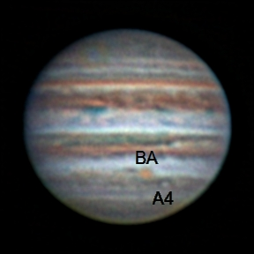

2017-05-25-0432\_1-Hill-Jupiter-RGB-Wavelets-Stuff-Annotated.jpg

|  |  |  |  |
| --- | --- | --- | --- |
| F:\Astronomy\Projects\Planets\Jupiter\Imaging Data\20170505UT\2017-05-05-0348_2-Jupiter_685NIR_Full-IoAligned-Stack50-Wavelets1x10+2x5-Cropped-2x.jpg | F:\Astronomy\Projects\Planets\Jupiter\Imaging Data\20170505UT\2017-05-05-0347_3-Jupiter_685NIR_Full-IoAligned-Stack100-Stretch0to64-Wavelets1x10+2x5-Cropped-2x.jpg | F:\Astronomy\Projects\Planets\Jupiter\Imaging Data\20170505UT\2017-05-05-0348_2-Jupiter_685NIR_Full-EuropaAligned-Stack40-Wavelets1x10+2x5-Cropped-2x.jpg | F:\Astronomy\Projects\Planets\Jupiter\Imaging Data\20170505UT\2017-05-05-0347_3-Jupiter_685NIR_Full-EuropaAligned-Stack100-Stretch0to64-Wavelets1x10+2x5-Cropped-2x.jpg |
| 2017-05-05-0348\_2-Jupiter\_685NIR\_Full-IoAligned-Stack50-Wavelets1x10+2x5-Cropped-2x.jpg | 2017-05-05-0347\_3-Jupiter\_685NIR\_Full-IoAligned-Stack100-Stretch0to64-Wavelets1x10+2x5-Cropped-2x.jpg | 2017-05-05-0348\_2-Jupiter\_685NIR\_Full-EuropaAligned-Stack40-Wavelets1x10+2x5-Cropped-2x.jpg | 2017-05-05-0347\_3-Jupiter\_685NIR\_Full-EuropaAligned-Stack100-Stretch0to64-Wavelets1x10+2x5-Cropped-2x.jpg |

20170505T0347.3UT



20170505T0348.2UT



Two videos were taken, one at 0347.3UT and the other at 0348.2UT. The first one used very short exposures with a linear gamma. The other used much longer exposures. Using the relative positions of Io and Europa the astrometrically determined plate scale was found to be 0.1726±0.002 arcsec-pixel-1. This is very close to the previously determined 0.1734 arcsec-pixel-1 determined from 20170414UT (about a 0.46% difference).

The difference between the two videos is evident in the effective system resolution. For the short exposures at 0347.3UT the resolution is 0.580±0.040 arcsec (95% confidence). For the long exposures at 0348.2UT the resolution is 0.815±0.019 arcsec. Note that the estimated resolution determined independent of the plate scale pretty consistent at 0.860 and 0.728 arcsec.

**Data Disposition:** Raw data are zipped and on the 2TB archive drive. Processed data are under the Projects directory on the Astronomy thumb drive.

## June

### 2017-Jun-04 (Jun-05 UT): Jupiter, Io and Moon

Last Updated 6/5/2017

Very steady seeing (4.5/5!?) and very good transparency. Linear gamma on CH4 and NUV.

|  |  |
| --- | --- |
| F:\Astronomy\Projects\Planets\Jupiter\Imaging Data\20170605UT\2017-06-05-0329_8-Hill-Jupiter-RGB-Wavelets.png | F:\Astronomy\Projects\Planets\Jupiter\Imaging Data\20170605UT\2017-06-05-0333_6-Hill-Jupier-807-685-RED-Wavelets.png |
| 2017-06-05-0329\_8-Hill-Jupiter-RGB-Wavelets.png | 2017-06-05-0333\_6-Hill-Jupier-807-685-RED-Wavelets.png |
| F:\Astronomy\Projects\Planets\Jupiter\Imaging Data\20170605UT\2017-06-05-0340_1-Hill-Jupiter-CH4-GRN-NUV-Wavelets.png | F:\Astronomy\Projects\Planets\Jupiter\Imaging Data\20170605UT\2017-06-05-0338_4-Hill-807-GRN-NUV-Wavelets.png |
| 2017-06-05-0340\_1-Hill-Jupiter-CH4-GRN-NUV-Wavelets.png | 2017-06-05-0338\_4-Hill-807-GRN-NUV-Wavelets.png |

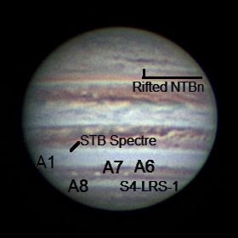

2017-06-05-0329\_8-Hill-Jupiter-RGB-Wavelets-Annotated

### 2017-Jun-14 (Jun-15 UT): Jupiter, Europa and Ganymede

Last Updated 6/5/2017

First time with new Dell Inspiron 13. Worked very well. Upgraded SharpCap 3.X wanted to take LX videos and save as a sequence of PNGs. Not sure how to get past that right now. Aha, I can use MaximDL to make AVI files from the individual PNGs. I tried it and then stacked the AVI successfully in Registax.

|  |  |
| --- | --- |
| C:\Users\Steven Hill\AppData\Local\Microsoft\Windows\INetCache\Content.Word\2017-06-15-0319_8-Hill-Jupiter-RGB-Wavelets.jpg | C:\Users\Steven Hill\AppData\Local\Microsoft\Windows\INetCache\Content.Word\2017-06-15-0325_7-Hill-Jupiter-807-685-RED-Wavelets.jpg |
| 2017-06-15-0319\_8-Hill-Jupiter-RGB-Wavelets.jpg | 2017-06-15-0325\_7-Hill-Jupiter-807-685-RED-Wavelets.jpg |
| C:\Users\Steven Hill\AppData\Local\Microsoft\Windows\INetCache\Content.Word\2017-06-15-0337_9-Hill-Jupiter-CH4-GRN-NUV-Wavelets.jpg | C:\Users\Steven Hill\AppData\Local\Microsoft\Windows\INetCache\Content.Word\2017-06-15-0334_0-Hill-Jupiter-807-GRN-NUV-Wavelets.jpg |
| 2017-06-15-0337\_9-Hill-Jupiter-CH4-GRN-NUV-Wavelets.jpg | 2017-06-15-0334\_0-Hill-Jupiter-807-GRN-NUV-Wavelets |

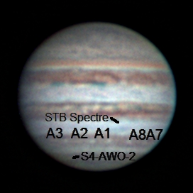

2017-06-15-0319\_8-Hill-Jupiter-RGB-Wavelets-Annotated.jpg

### 2017-Jun-15 (Jun-16 UT): Jupiter, Saturn

Last Updated 6/5/2017

Very steady seeing (4.5/5!?) and very good transparency. Linear gamma on CH4 and NUV.

|  |  |
| --- | --- |
| C:\Users\Steven Hill\AppData\Local\Microsoft\Windows\INetCache\Content.Word\2017-06-16-0423_9-Hill-Jupiter-Composit-Wavelets.jpg | C:\Users\Steven Hill\AppData\Local\Microsoft\Windows\INetCache\Content.Word\2017-06-16-0428_9-Hill-Jupiter-807-685-RED-Composite-Wavelets.png |
| 2017-06-16-0423\_9-Hill-Jupiter-Composit-Wavelets.jpg | 2017-06-16-0428\_9-Hill-Jupiter-807-685-RED-Composite-Wavelets.jpg |
| C:\Users\Steven Hill\AppData\Local\Microsoft\Windows\INetCache\Content.Word\2017-06-16-0437_1-Hill-Jupiter-889-GRN-NUV-Composite-Wavelets.jpg | C:\Users\Steven Hill\AppData\Local\Microsoft\Windows\INetCache\Content.Word\2017-06-16-0434_4-Hill-Jupiter-807-GRN-NUV-Composite-Wavelets.jpg |
| 2017-06-16-0437\_1-Hill-Jupiter-889-GRN-NUV-Composite-Wavelets.jpg | 2017-06-16-0434\_4-Hill-Jupiter-807-GRN-NUV-Composite-Wavelets |
|  |  |

NOTE: I NEED TO RECONCILE THE TIME TAGGING IN 889CH4 FILENAMES WITH THE MID-EXPOSURE TIMES. AND, THEN I NEED TO REDO FALSE COLOR RGB IMAGES USING 889CH4.

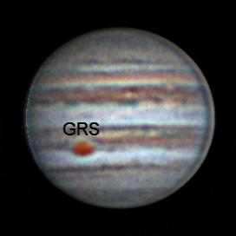

2017-06-16-0423\_9-Hill-Jupiter-Composit-Wavelets-Annotated.jpg

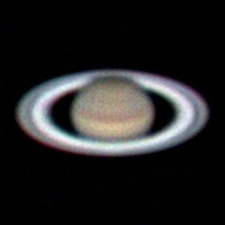

2017-06-16-0519\_6-Hill-Saturn-RGB-Wavelets.jpg

**Data Disposition:** Raw data are zipped and ready to be moved to the 2TB archive drive. Processed data are under the Projects directory on the Astronomy thumb drive.

## July

### Summer 2017 Planning

Last Updated 1/23/2017

* Observations
  + Imaging
    - Eclipse
    - M101
    - NGC5907
    - NGC5985 – Draco Triple
    - NGC5905 – Draco Double
    - M8 - Lagoon
    - M21 - Trifid
    - M17 - Swan
    - M16 - Eagle
  + Video
    - Eclipse
    - Saturn
    - Cat’s Eye
    - 17 Dra
    - Mu Dra
    - 61 Cyg
    - Zet Her – STF2085
    - 99 Her
    - Eps Lyr
    - BU 648
    - Lam Oph
    - Tau Oph
    - 70 Oph
    - STF 2173
    - Del Serp
  + Spectra
    - Saturn
    - Titan (Sep 1UT good eastern elongation, Sep 06-10UT good western elongation)
    - Cat’s Eye
    - Bet Lyr 135mm x 200lpm
* Analysis
  + M31 Multispectral Analysis *ala* M33, M81, M101 etc.
  + Solar Eclipse Preparation
  + Questions for OPT:
    - Motorized Focuser
    - Custom Filters
    - NII filter

## August

### 2017-Aug-01 (Aug-02 UT): Moon and Saturn

Last Updated 8/6/2017

Very steady seeing (4/5) and very good transparency.

|  |  |
| --- | --- |
| C:\Users\Steven Hill\AppData\Local\Microsoft\Windows\INetCache\Content.Word\2017-08-02-0401_5-Hill-Saturn-RGB-Wavelets-WhtBal-Stuff.png |  |
| 2017-08-02-0401\_5-Hill-Saturn-RGB-Wavelets-WhtBal-Stuff.png | TBD |

|  |  |  |  |  |  |
| --- | --- | --- | --- | --- | --- |
| Filter | Gamma | Gain | Brightness | Exposure | LT |
| NUV | 50 | 100 | 0 | 3929 ms |  |
| BLU | 50 | 75 | 0 | 148 ms |  |
| GRN | 50 | 75 | 0 | 85 ms |  |
| RED | 50 | 75 | 0 | 148 ms |  |
| >685 | 50 | 75 | 0 | 87 ms |  |
| >807 | 50 | 75 | 0 | 374 ms |  |
| 889CH4 | 50 | 100 | 0 | 3929 ms |  |

For Saturn, I need to:

* Produce various combinations of RGB images
* Document videos and camera settings
* Identify which images have which moons visible
* Determine effects of gains settings for photometry of moons
* Do a polar map for the hexagon (maybe)
* Do a polar map for the rings
* Do an equatorial map for the bands.
* Archive data

For the Moon, I need to:

* Document videos and camera settings
* Attempt multi-focus alignment as opposed to single focus alignement
* Do some LTVT aerial projection maps
* Do some LTVT elevation measures
* Archive data

Moon Targets:

1. Copernicus
2. Plato and Imbrium (2x)
3. Alpine Valley and Cassini
4. Posidonius and dark flow of Serenitatis
5. Rima Hyginus
6. Pitatus and Hesiodus

Note that moon images were stacked with a single alignment area each focused on the feature of greatest interest, e.g., Plato.

|  |  |
| --- | --- |
| C:\Users\Steven Hill\AppData\Local\Microsoft\Windows\INetCache\Content.Word\2017-08-02-0220_5-Moon_685NIR-Stack350-Wavelets1x30+2x15-Gam50pct-HalfSize.jpg | C:\Users\Steven Hill\AppData\Local\Microsoft\Windows\INetCache\Content.Word\2017-08-02-0222_5-Moon_685NIR-Mosaic-HalfSize.jpg |
| 2017-08-02-0220\_5-Moon\_685NIR-Stack350-Wavelets1x30+2x15-Gam50pct-HalfSize.jpg | 2017-08-02-0222\_5-Moon\_685NIR-Mosaic-HalfSize.jpg |
| C:\Users\Steven Hill\AppData\Local\Microsoft\Windows\INetCache\Content.Word\2017-08-02-0224_7-Moon_685NIR-Stack500-Wavelets1x30+2x10-Gam80pct-HalfSize.jpg | C:\Users\Steven Hill\AppData\Local\Microsoft\Windows\INetCache\Content.Word\2017-08-02-0226_5-Moon_685NIR-Stack500-Wavelets1x20+1x20-Gam60pct-HalfSize.jpg |
| 2017-08-02-0224\_7-Moon\_685NIR-Stack500-Wavelets1x30+2x10-Gam80pct-HalfSize.jpg | 2017-08-02-0226\_5-Moon\_685NIR-Stack500-Wavelets1x20+1x20-Gam60pct-HalfSize.jpg |
| C:\Users\Steven Hill\AppData\Local\Microsoft\Windows\INetCache\Content.Word\2017-08-02-0228_4-Moon_685NIR-Stack500-Wavelets1x20+2x20-Gam60pct-HalfSize.jpg | C:\Users\Steven Hill\AppData\Local\Microsoft\Windows\INetCache\Content.Word\2017-08-02-0233_4-Moon_685NIR-Stack350-Wavelets1x20+2x20-Gam60pct-HalfSize.jpg |
| 2017-08-02-0228\_4-Moon\_685NIR-Stack500-Wavelets1x20+2x20-Gam60pct-HalfSize.jpg | 2017-08-02-0233\_4-Moon\_685NIR-Stack350-Wavelets1x20+2x20-Gam60pct-HalfSize.jpg |

**Data Disposition:** TBD

### 2017-Aug-18 (Aug-18 UT): Sun Imaging Tests

Last Updated 8/6/2017

Very steady seeing (4/5) and very good transparency.

|  |  |
| --- | --- |
| C:\Users\Steven Hill\AppData\Local\Microsoft\Windows\INetCache\Content.Word\2017-08-02-0401_5-Hill-Saturn-RGB-Wavelets-WhtBal-Stuff.png |  |
| 2017-08-02-0401\_5-Hill-Saturn-RGB-Wavelets-WhtBal-Stuff.png | TBD |

### 2017-Aug-21 (Aug-21 UT): Eclipse in Alliance, Nebraska!

Last Updated 8/6/2017

TO DO:

* Finish stacking all totality images from 500D – and document
* Create HDR master from 500D stacked images – and document
* Process all partial phase NIR video – and document
* Process all partial phase 500D images
* Make NIR Video
* Make 500D video
* Archive data

A wide range of images were taken using the Canon EOS Rebel 500D at 300mm and the ASI120MM with the 135mm lens and the >807nm NIR filter.

It would be a good idea to take some dark frames, flat fields and flux calibration images with known sources, e.g., sky for flats and Vega for flux with the different configurations used at the eclipse.

Notes on NIR images…

Very steady seeing (4/5) and very good transparency.

|  |  |
| --- | --- |
| C:\Users\Steven Hill\AppData\Local\Microsoft\Windows\INetCache\Content.Word\2017-08-21-1750_4-Sun_807NIR-Stack145-Gam3-Wavelets1x10+2x5+3x3+4x3-Color.jpg | C:\Users\Steven Hill\AppData\Local\Microsoft\Windows\INetCache\Content.Word\2017-08-21-1752_4-Sun_807NIR_Totality-Stack600-Gam2-Wavelets1x20+2x10+3x5+4x5-Color-Crop.jpg |
| 2017-08-21-1750\_4-Sun\_807NIR-Stack145-Gam3-Wavelets1x10+2x5+3x3+4x3-Color.jpg | 2017-08-21-1752\_4-Sun\_807NIR\_Totality-Stack600-Gam2-Wavelets1x20+2x10+3x5+4x5-Color-Crop.jpg |
| C:\Users\Steven Hill\AppData\Local\Microsoft\Windows\INetCache\Content.Word\2017-08-21-1752_4-Sun_807NIR_DiamondRing-Stack47-Gam2-Wavelets1x10+2x5-Color-Crop.jpg | C:\Users\Steven Hill\AppData\Local\Microsoft\Windows\INetCache\Content.Word\SXI-Stack3-Log-Filtered-Wavelets1-Rot-Color-Crop.jpg |
| 2017-08-21-1752\_4-Sun\_807NIR\_DiamondRing-Stack47-Gam2-Wavelets1x10+2x5-Color-Crop.jpg | SXI-Stack3-Log-Filtered-Wavelets1-Rot-Color-Crop.jpg |

**2017-08-21-1750\_4-Sun\_807NIR: Exposure=0.009433; Gain=50; Gamma=50**

This sequence only had 145 frames for a total exposure of 1.3678 seconds. I terminated it early once I realized I wasn’t capturing too much of the corona. Rather than increase exposure or gain, which would saturate the inner coronal, I increased gamma to near the maximum for the next sequence. However, with gamma set to 50 for this sequence, the response should be linear.

**2017-08-21-1752\_4-Sun\_807NIR: Exposure=0.009433; Gain=50; Gamma=95**

This sequence uses near maximum gamma. It is an extended sequence with 2253 frames. The sequence was initiated during totality and the first 600 frames cover totality for a total exposure of 5.6598 seconds. Frames from 650 to 697 show the diamond ring. Between 600 and 650 is a hard to characterize transition between totality and the diamond ring. Further examination may show a good example of Bailey’s Beads. At about frame 698 I replaced the NIR + 2xND filters to return to the partial phase. The last TBD frames show the crescent Sun.

|  |  |
| --- | --- |
| C:\Users\Steven Hill\AppData\Local\Microsoft\Windows\INetCache\Content.Word\Totality-20170821UT--0006-001ms-Aligned_thru_016ms-SmartMergeCurve-Wavelets2-Sat150-Crop-HalfSize.jpg | C:\Users\Steven Hill\AppData\Local\Microsoft\Windows\INetCache\Content.Word\Totality-20170821UT--0006-001ms-Aligned_thru_512ms-SmartMergeCurve-Gam-Wavelets2-Sat130pct-Crop-HalfSize.jpg |
| Totality-20170821UT--0006-001ms-Aligned\_thru\_016ms-SmartMergeCurve-Wavelets2-Sat150-Crop-HalfSize.jpg | Totality-20170821UT--0006-001ms-Aligned\_thru\_512ms-SmartMergeCurve-Gam-Wavelets2-Sat130pct-Crop-HalfSize.jpg |
| C:\Users\Steven Hill\AppData\Local\Microsoft\Windows\INetCache\Content.Word\Totality-20170821UT--0006-064ms-thru-512ms-Wavelets-Filtered-HalfSize.jpg | C:\Users\Steven Hill\AppData\Local\Microsoft\Windows\INetCache\Content.Word\Totality-20170821UT--0006-001ms-Aligned_thru_512ms-SmartMergeCurve-Gam-Wavelets2-Sat130pct-Crop-HalfSize-ExtrStr.jpg |
| Totality-20170821UT--0006-064ms-thru-512ms-Wavelets-Filtered-HalfSize.jpg | Totality-20170821UT--0006-001ms-Aligned\_thru\_512ms-SmartMergeCurve-Gam-Wavelets2-Sat130pct-Crop-HalfSize-ExtrStr.jpg |

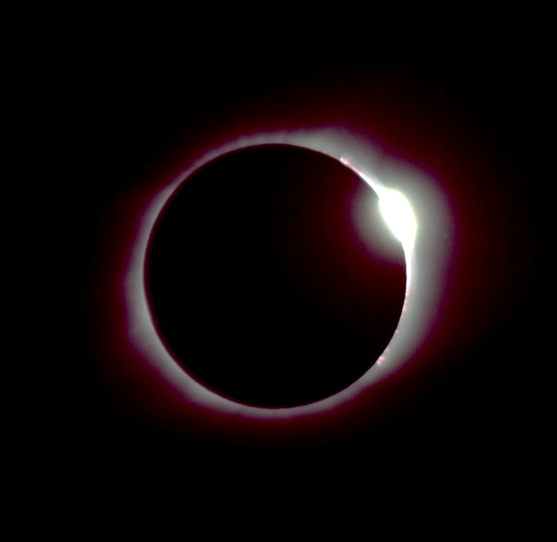

Totality-20170821UT--0007-004ms-Converted-Edited-DiamondRing.jpg

### 2017-Aug-28 (Aug-29 UT): Saturn Video

Last Updated 8/30/2017

Very steady seeing (4/5) and good transparency. But, Saturn was very low (20-25 deg elevation; airmass ~2.4-2.9). Best achievable elevation is only 28 deg (airmass ~2.1) at transit!

|  |  |
| --- | --- |
| C:\Users\Steven Hill\AppData\Local\Microsoft\Windows\INetCache\Content.Word\2017-08-29-0351_2-Hill-Saturn-Composite-RGB-Wavelets.png |  |
| 2017-08-02-0401\_5-Hill-Saturn-RGB-Wavelets-WhtBal-Stuff.png | TBD |

Old Jupiter stuff is included as an FYI and to inform predictions for Uranus and Neptune camera settings.

|  |  |  |  |  |  |
| --- | --- | --- | --- | --- | --- |
| Filter | Gamma | Gain | Brightness | Exposure | LT |
| GRN | 50 | 50 | 0 | 68 ms | 9:54 pm |
| BLU | 50 | 50 | 0 | 68 ms | 10:01 pm |
| NUV | 50 | 100 | 0 | 1251 ms | 10:03 am |
| >685 | 50 | 50 | 0 | 122 ms | 10:12 pm |
| >807 | 50 | 50 | 0 | 523 ms | 10:17 pm |
| CH4 | 100 | 100 | 0 | 2200 ms | 10:33 pm |

Some different Saturn exposure times were tried. This table needs to be updated to include them.

|  |  |  |  |  |  |
| --- | --- | --- | --- | --- | --- |
| Filter | Gamma | Gain | Brightness | Exposure | LT |
| BLU | 50 | 70 | 0 | 200 ms |  |
| GRN | 50 | 70 | 0 | 150 ms |  |
| RED | 50 | 70 | 0 | 150 ms |  |
| >685 | 50 | 70 | 0 | 150 ms |  |

I need to:

* Produce various combinations of RGB images
* Document videos and camera settings
* Identify which images have which moons visible
* Determine effects of gains settings for photometry of moons
* Do a polar map for the hexagon (maybe)
* Do a polar map for the rings
* Do an equatorial map for the bands.
* Archive data

**Data Disposition:** TBD

## September

### 2017-Sep-06 (Sep-06 UT): Sun – AR 12673

Last Updated 9/7/2017

Steady seeing (3.5/5), but very poor transparency due to wildfire smoke.

|  |  |
| --- | --- |
| C:\Users\Steven Hill\AppData\Local\Microsoft\Windows\INetCache\Content.Word\2017-09-06-2XXX_X-RGB-WhtBal-ClrSmth-Sat200pct-FlatCrop-Wavelets-Sat200pct-HalfSize.jpg | C:\Users\Steven Hill\AppData\Local\Microsoft\Windows\INetCache\Content.Word\2017-09-06-2XXX_X-IGU-WhtBal-ClrSmth-Sat200pct-FlatCrop-Wavelets-HalfSize.jpg |
| 2017-09-06-2XXX\_X-RGB-WhtBal-ClrSmth-Sat200pct-FlatCrop-Wavelets-Sat200pct-HalfSize.jpg | 2017-09-06-2XXX\_X-IGU-WhtBal-ClrSmth-Sat200pct-FlatCrop-Wavelets-HalfSize.jpg |

This region produced major activity. I should provide contemporary images from X-ray and EUV observatories as well as a timeline of activity over a few days prior and subsequent to my observations. This would best be included in the solar report rather than in this annual observation report.

I need to fully document the individual videos and camera settings for this observation.

**Data Disposition:** Raw data are zipped and ready to be moved to the 2TB archive drive. Processed data are under the Projects directory on the Astronomy thumb drive.

## October

### 2017-Oct-07 (Oct-08 UT): Epsilon Lyrae, Lam Aqr

Last Updated 9/7/2017

Moderate seeing (3/5) and good transparency (4/5). I couldn’t find Neptune. Used Vega as a drift star for PA and scale calibration.

|  |  |  |  |
| --- | --- | --- | --- |
| **Eps Lyr 1** | | **Eps Lyr 2** | |
| C:\Users\Steven Hill\AppData\Local\Microsoft\Windows\INetCache\Content.Word\2017-10-08-0318_3-EPSLYR1_B_685NIR-Stack150-Wavelets1x3+2x5+3x3-Str0to128-RotCrop.jpg | 2017-10-08-0318\_3-EPSLYR1\_B\_685NIR-Stack150-Wavelets1x3+2x5+3x3-Str0to128-RotCrop.jpg | C:\Users\Steven Hill\AppData\Local\Microsoft\Windows\INetCache\Content.Word\2017-10-08-0309_2-EPSLYR2_A_685NIR-Stack150-Wavelets1x3+2x5+3x3-Str0to128-RotCrop.jpg | 2017-10-08-0309\_2-EPSLYR2\_A\_685NIR-Stack150-Wavelets1x3+2x5+3x3-Str0to128-RotCrop.jpg |
| **Lam Aqr** | |  | |
| C:\Users\Steven Hill\AppData\Local\Microsoft\Windows\INetCache\Content.Word\2017-10-08-0436_8-LamAqr_685NIR_00000thru06002-Stack600-Wavelets2x3+3x3-RotCrop.jpg | 2017-10-08-0436\_8-LamAqr\_685NIR\_00000thru06002-Stack600-Wavelets2x3+3x3-RotCrop.jpg |  |  |

**(In order to get proper orientation, rotate by “rotation minus 90 degrees”, clockwise in MaximDL.)**

**Data Disposition:** Raw data is zipped on laptop ready to move to 2TB archive drive. Processed data is on Astronomy3 thumb drive.

### Fall 2017 Planning

Last Updated 10/27/2017

* Observations – ~~Nov. 6 transit times~~ Nov. ~~16~~ 28 first visibility times; Dark around 5:30pm
  + Imaging – wide field
    - ~~5:41pm~~ - Veil Nebula / Cygnus Loop – wide field (got full narrow band imaging)
    - **5:00pm** - **IC1396 - Elephant Trunk –** wide field (Need~~486HIB~~**,** ~~380NUV~~**,** ~~807NIR~~, ~~742NIR~~, 685NIR, 889CH4**)**
    - ~~8:00pm~~ - Cave and Bubble – wide field (need at least 486HIB, maybe 656HIA); cover a broader range to the south with large, hot emission
    - **6:30pm - NGC7822 – wide field (need** ~~486HIB~~**,** ~~380NUV~~**,** ~~807NIR, 742NIR,~~ 685NIR, 889CH4**)**
    - **7:00pm** - **M31**– wide field (replace **656HIA, 807NIR,** **742NIR, 672SII – more, 486HIB - more**,)
    - **9:00pm** - **Heart and Soul** – **wide field** (need ~~672SII,~~ ~~501OIII~~, **486HIB**, ~~807NIR~~, ~~742NIR~~, 889CH4)
    - 10:00pm – M45 Pleiades
    - 10:30pm – NGC1499 California Nebula
    - 12:00am – Simeis 147
  + Video
    - **5:00pm (6:20pm transit) -Neptune – need good seeing!!! –**
    - **5:00pm - NGC7662 Blue Snowball nebula**
    - **8:00pm – Uranus – need good seeing**
    - 61 Cyg
    - Mu Cyg
    - 6:00pm - NGC7009 – Saturn Nebula (already have video) - Capricorn
  + Imaging – 1260mm
    - 8:00pm – M33 – **1260mm** (need **all narrow band images**)
    - 12:00am – M1 Crab Nebula – **1260mm** (need **all narrow band images**)
  + Spectra
    - 5:00pm - Neptune – 1260mm, 100lpm
    - 5:00pm - Triton – 1260mm, 100lpm
    - 8:00pm - Uranus – 1260mm, 100lpm
* Analysis
  + M31 Multispectral Analysis *ala* M33, M81, M101 etc.
  + Solar Eclipse Movies, ratio analysis, etc.
  + Updated spectral analysis for outer planets
  + Questions for OPT:
    - GoTo Mounts
    - Motorized Focuser
    - Custom Filters
    - NII filter

Neptune exposure planning. Saturn is twice as far from the Sun as Jupiter and so has roughly one fourth the surface brightness. To compensate, gain was raised from 50 to 70-75 and exposures were increase by a factor of ~2.2. This suggests the gain increase provided about 4/2.2~1.8 of the needed increase in response.

Neptune is 3 times farther than Saturn and therefore one ninth the surface brightness. If we keep the gain the same (75-ish), we will need exposures of 750 to 1350 ms for BLU, GRN, RED and >685. Exposures of about 3400 ms might work for >807. NUV and 889CH4 images will likely not be feasible. Dark frames might be a good idea.

If we increase the gain to 100, it would probably be a good idea to use dark frames. If we assume that the gain increase can provide a factor of ~2 in signal, the exposures would range from 400 to 700 ms for BLU, GRN, RED and >685. Exposures of about 1700 ms might work for >807. For NUV and CH4, detections might be possible for exposures >10000 ms. While unlikely to provide any spatial resolution, these might be useful for photometry.

Uranus exposure planning. Saturn is twice as far from the Sun as Jupiter and so has roughly one fourth the surface brightness. To compensate, gain was raised from 50 to 70-75 and exposures were increase by a factor of ~2.2. This suggests the gain increase provided about 4/2.2~1.8 of the needed increase in response.

Uranus is 2 times farther than Saturn and therefore one fourth the surface brightness. If we keep the gain the same (75-ish), we will need exposures of 330 to 600 ms for BLU, GRN, RED and >685. Exposures of about 1500 ms might work for >807. NUV and 889CH4 images will likely not be feasible. Dark frames might be a good idea.

If we increase the gain to 100, it would probably be a good idea to use dark frames. If we assume that the gain increase can provide a factor of ~2 in signal, the exposures would range from 160 to 300 ms for BLU, GRN, RED and >685. Exposures of about 900 ms might work for >807. For NUV and CH4, detections might be possible for exposures >10000 ms. While unlikely to provide any spatial resolution, these might be useful for photometry.

### 2017-Oct-10 (Oct-11 UT): Double Stars, Neptune and Triton

Last Updated 9/7/2017

Steady seeing (4/5) and very good transparency (5/5).

All the double stars imaged used a gain of 100. Gamma was set to 50 for linear response. This means that the stars are suitable for photometry and comparison to 685NIR channel photometry for Neptune.

|  |  |  |  |
| --- | --- | --- | --- |
| **Zet Her** | | **Zet Her** | |
| C:\Users\Steven Hill\AppData\Local\Microsoft\Windows\INetCache\Content.Word\2017-10-11-0205_9-ZetHer_685NIR_Rot1-Stack200-Wavelets1x10+2x10-RotCrop.jpg | 2017-10-11-0205\_9-ZetHer\_685NIR\_Rot1-Stack200-Wavelets1x10+2x10-RotCrop.jpg | C:\Users\Steven Hill\AppData\Local\Microsoft\Windows\INetCache\Content.Word\2017-10-11-0205_9-ZetHer_685NIR_Rot1-Stack200-Wavelets1x10+2x10-RotGrad-RotCrop.jpg | 2017-10-11-0205\_9-ZetHer\_685NIR\_Rot1-Stack200-Wavelets1x10+2x10-RotGrad-RotCrop.jpg |
| **17 Dra** | | **Tau Oph** | |
| C:\Users\Steven Hill\AppData\Local\Microsoft\Windows\INetCache\Content.Word\2017-10-11-0221_9-17Dra_685NIR_Rot1-Stack200-Wavelets1x10+2x10-RotCrop.jpg | 2017-10-11-0221\_9-17Dra\_685NIR\_Rot1-Stack200-Wavelets1x10+2x10-RotCrop.jpg | C:\Users\Steven Hill\AppData\Local\Microsoft\Windows\INetCache\Content.Word\2017-10-11-0154_0-TAU_685NIR-Stack200-Wavelets1x10+2x10-RotCrop.jpg | 2017-10-11-0154\_0-TAU\_685NIR-Stack200-Wavelets1x10+2x10-RotCrop.jpg |
| **BU 648** | | **70 Oph** | |
| C:\Users\Steven Hill\AppData\Local\Microsoft\Windows\INetCache\Content.Word\2017-10-11-0211_7-BU648_685NIR_Rot1-Stack200-Wavelets1x10+2x10-RotCrop.jpg | 2017-10-11-0211\_7-BU648\_685NIR\_Rot1-Stack200-Wavelets1x10+2x10-RotCrop.jpg | C:\Users\Steven Hill\AppData\Local\Microsoft\Windows\INetCache\Content.Word\2017-10-11-0141_7-70OPH_685NIR-Stack200-Wavelets1x10+2x10-RotCrop.jpg | 2017-10-11-0141\_7-70OPH\_685NIR-Stack200-Wavelets1x10+2x10-RotCrop.jpg |

NeptuneExposures-20171011UT.xlsx



The star HD216566 (TYC 5813-0377-1) is visible in all exposures. It is a 9.32mV K0III star with a color index of +1.20 (orange). Neptune photometry should be possible in all channels and Triton photometry should be possible in BLU, GRN(?), NIR and OPN channels.

From SIMBAD:

<http://simbad.u-strasbg.fr/simbad/sim-id?Ident=HD+216566&submit=submit+id>

**B 10.52 [0.05] D**[**2000A&A...355L..27H**](http://simbad.u-strasbg.fr/simbad/sim-ref?bibcode=2000A%26A...355L..27H)

**V 9.31 [0.02] D**[**2000A&A...355L..27H**](http://simbad.u-strasbg.fr/simbad/sim-ref?bibcode=2000A%26A...355L..27H)

**G 8.975 [0.002] C**[**2016A&A...595A...2G**](http://simbad.u-strasbg.fr/simbad/sim-ref?bibcode=2016A%26A...595A...2G)

**J 7.498 [0.030] C**[**2003yCat.2246....0C**](http://simbad.u-strasbg.fr/simbad/sim-ref?bibcode=2003yCat.2246....0C)

**H 7.037 [0.051] C**[**2003yCat.2246....0C**](http://simbad.u-strasbg.fr/simbad/sim-ref?bibcode=2003yCat.2246....0C)

**K 6.814 [0.026] C**[**2003yCat.2246....0C**](http://simbad.u-strasbg.fr/simbad/sim-ref?bibcode=2003yCat.2246....0C)

Other references: (Mallama, Krobusek, & Pavlov, 2017); (Buratti et al., 2011; Pascu et al., 2006)

Also, Lowell updates to Lockwood work: <http://www2.lowell.edu/users/wes/U_N_lcurves.pdf>, and there’s a Schmude paper from 2015 I have in my Neptune references folder, but not in EndNote. Also, there’s a good quick summary of bands on Wikipedia [here](https://en.wikipedia.org/wiki/Photometric_system#Photometric_letters).

Especially relevant for the (Mallama et al., 2017)paper is understanding the conversion from absolute to apparent magnitude. Wikipedia provides a decent explanation [here](https://en.wikipedia.org/wiki/Absolute_magnitude#Solar_System_bodies_(H)).

Phase angle and absolute magnitude <http://www.astro.gla.ac.uk/~martin/a1notes/pos_astro/PA10.pdf>

|  |  |  |  |
| --- | --- | --- | --- |
| C:\Users\Steven Hill\AppData\Local\Microsoft\Windows\INetCache\Content.Word\Neptune-685NIR-Long 2017-10-11-0428_5-Stack30-Str0to128-Wavelets5x3+6x3-RotCrop.jpg | C:\Users\Steven Hill\AppData\Local\Microsoft\Windows\INetCache\Content.Word\Neptune-685NIR-Long 2017-10-11-0428_5-Stack30-Str0to128-Wavelets5x3+6x3-RotCrop-Log.jpg | C:\Users\Steven Hill\AppData\Local\Microsoft\Windows\INetCache\Content.Word\Neptune-685NIR-Long-Lin 2017-10-11-0431_4-Stack28-Str0to64-Wavelets3x3+4x3-RotCrop.jpg | C:\Users\Steven Hill\AppData\Local\Microsoft\Windows\INetCache\Content.Word\Neptune-685NIR-Long-Lin 2017-10-11-0431_4-Stack28-Str0to64-Wavelets3x3+4x3-RotCrop-Log.jpg |
| Neptune-685NIR-Long 2017-10-11-0428\_5-Stack30-Str0to128-Wavelets5x3+6x3-RotCrop.jpg | Neptune-685NIR-Long 2017-10-11-0428\_5-Stack30-Str0to128-Wavelets5x3+6x3-RotCrop-Log.jpg | Neptune-685NIR-Long-Lin 2017-10-11-0431\_4-Stack28-Str0to64-Wavelets3x3+4x3-RotCrop.jpg | Neptune-685NIR-Long-Lin 2017-10-11-0431\_4-Stack28-Str0to64-Wavelets3x3+4x3-RotCrop-Log.jpg |
| C:\Users\Steven Hill\AppData\Local\Microsoft\Windows\INetCache\Content.Word\Neptune-650RED-Long-Lin 2017-10-11-0433_8-Stack28-Str0to64-wavelets3x3+4x3-RotCrop.jpg | C:\Users\Steven Hill\AppData\Local\Microsoft\Windows\INetCache\Content.Word\Neptune-650RED-Long-Lin 2017-10-11-0433_8-Stack28-Str0to64-wavelets3x3+4x3-RotCrop-Log.jpg | C:\Users\Steven Hill\AppData\Local\Microsoft\Windows\INetCache\Content.Word\Neptune-550GRN-Long-Lin 2017-10-11-0438_8-Stack56-Str0to192-Wavelets2x3+3x3-RotCrop.jpg | C:\Users\Steven Hill\AppData\Local\Microsoft\Windows\INetCache\Content.Word\Neptune-550GRN-Long-Lin 2017-10-11-0438_8-Stack56-Str0to192-Wavelets2x3+3x3-RotCrop-Log.jpg |
| Neptune-650RED-Long-Lin 2017-10-11-0433\_8-Stack28-Str0to64-wavelets3x3+4x3-RotCrop.jpg | Neptune-650RED-Long-Lin 2017-10-11-0433\_8-Stack28-Str0to64-wavelets3x3+4x3-RotCrop-Log.jpg | Neptune-550GRN-Long-Lin 2017-10-11-0438\_8-Stack56-Str0to192-Wavelets2x3+3x3-RotCrop.jpg | Neptune-550GRN-Long-Lin 2017-10-11-0438\_8-Stack56-Str0to192-Wavelets2x3+3x3-RotCrop-Log.jpg |
| C:\Users\Steven Hill\AppData\Local\Microsoft\Windows\INetCache\Content.Word\Neptune-450BLU-Long-Lin 2017-10-11-0441_5-Stack54-Str0to192-Wavelets2x3+3x3-RotCrop.jpg | C:\Users\Steven Hill\AppData\Local\Microsoft\Windows\INetCache\Content.Word\Neptune-450BLU-Long-Lin 2017-10-11-0441_5-Stack54-Str0to192-Wavelets2x3+3x3-RotCrop-Log.jpg | C:\Users\Steven Hill\AppData\Local\Microsoft\Windows\INetCache\Content.Word\2017-10-11-0415_5-Neptune_550OPN-Stack300-Wavelets2x5+3x5-RotCrop.jpg | C:\Users\Steven Hill\AppData\Local\Microsoft\Windows\INetCache\Content.Word\2017-10-11-0415_5-Neptune_550OPN-Stack300-Wavelets2x5+3x5-RotCrop-Log.jpg |
| Neptune-450BLU-Long-Lin 2017-10-11-0441\_5-Stack54-Str0to192-Wavelets2x3+3x3-RotCrop.jpg | Neptune-450BLU-Long-Lin 2017-10-11-0441\_5-Stack54-Str0to192-Wavelets2x3+3x3-RotCrop-Log.jpg | 2017-10-11-0415\_5-Neptune\_550OPN-Stack300-Wavelets2x5+3x5-RotCrop.jpg | 2017-10-11-0415\_5-Neptune\_550OPN-Stack300-Wavelets2x5+3x5-RotCrop-Log.jpg |
| C:\Users\Steven Hill\AppData\Local\Microsoft\Windows\INetCache\Content.Word\Neptune-550OPN-Lomg 2017-10-11-0423_7-Stack30-Str0to64-Wavelets5x5-RotCrop.jpg | C:\Users\Steven Hill\AppData\Local\Microsoft\Windows\INetCache\Content.Word\Neptune-550OPN-Lomg 2017-10-11-0423_7-Stack30-Str0to64-Wavelets5x5-RotCrop-Log.jpg |  |  |
| Neptune-550OPN-Lomg 2017-10-11-0423\_7-Stack30-Str0to64-Wavelets5x5-RotCrop.jpg | Neptune-550OPN-Lomg 2017-10-11-0423\_7-Stack30-Str0to64-Wavelets5x5-RotCrop-Log.jpg |  |  |

### 2017-Oct-14 (Oct-15 UT): Veil Nebula, M31 Wide-Field

Last Updated 9/7/2017

Very good transparency (5/5), but poor seeing (3/5). For some odd reason the laptop rebooted after just six Veil Nebula images. It was probably a Windows update. However, I lost two hours of imaging. I got so frustrated, that I stayed up late setting up to image M31. The next day I looked at my last M31 imaging at this focal length and found I still had a lot of missing exposure time in various filters.

|  |  |
| --- | --- |
| C:\Users\Steven Hill\AppData\Local\Microsoft\Windows\INetCache\Content.Word\Veil-20171015UT-501OIII-sum0h30m-Log-HalfSize.jpg |  |
| Veil-20171015UT-501OIII-sum0h30m-Log-HalfSize.jpg |  |
| C:\Users\Steven Hill\AppData\Local\Microsoft\Windows\INetCache\Content.Word\M31-20171015UT-486HIB-sum2h00m-Log-HalfSize.jpg | C:\Users\Steven Hill\AppData\Local\Microsoft\Windows\INetCache\Content.Word\M31-20171015UT-501OIII-sum2h00m-Log-HalfSize.jpg |
| M31-20171015UT-486HIB-sum2h00m-Log-HalfSize.jpg | M31-20171015UT-501OIII-sum2h00m-Log-HalfSize.jpg |

### 2017-Oct-15 (Oct-16 UT): Veil Nebula Wide-Field

Last Updated 10/16/2017

Very good transparency (5/5), but poor seeing (3/5). I took a new set of darks and biases since the ones I took yesterday seem to be problematic, especially the 300 second dark frames.

|  |  |
| --- | --- |
| C:\Users\Steven Hill\AppData\Local\Microsoft\Windows\INetCache\Content.Word\Veil-20171016UT-501OIII-sum1h00m-Log-HalfSize.jpg | C:\Users\Steven Hill\AppData\Local\Microsoft\Windows\INetCache\Content.Word\Veil-20171016UT-486HIB-sum1h05m-Log-HalfSize.jpg |
| Veil-20171016UT-501OIII-sum1h00m-Log-HalfSize.jpg | Veil-20171016UT-486HIB-sum1h05m-Log-HalfSize.jpg |
| C:\Users\Steven Hill\AppData\Local\Microsoft\Windows\INetCache\Content.Word\Veil-2017101XUT-501OIII-sum1h30m-Log-HalfSize.jpg |  |
| Veil-2017101XUT-501OIII-sum1h30m-Log-HalfSize.jpg |  |

### 2017-Oct-17 (Oct-18 UT): Veil Nebula - Wide-Field, 380NUV

Last Updated 10/18/2017

Moderate transparency (3.5/5) degrading to very poor transparency (1/5). Poor seeing (3/5). The frames were unguided due to the lack of a sufficiently bright guide star. One exposure of five minutes was included. However, it showed trailing of 2-3 pixels so the remaining images were all two-minute exposures. In addition, the flat field from 501OIII was used as of the processing date (2017-10-18UT) because no NUV flat was available. The flat used did a reasonably good job, but processing should be repeated with a proper NUV flat.

Given that the Veil nebula has essentially no reflection component, its detection in the NUV must either be out of band contamination or emission from OII 372.6 nm and/or Ne III 386.9 nm (Parker, 1964).

|  |
| --- |
| C:\Users\Steven Hill\AppData\Local\Microsoft\Windows\INetCache\Content.Word\Veil-20171018UT-380NUV-sum2h05m-Flattened-Log-HalfSize.jpg |
| Veil-20171016UT-501OIII-sum1h00m-Log-HalfSize.jpg |

### 2017-Oct-18 (Oct-19 UT): Neptune

Last Updated 10/18/2017

Seeing was good (3.5/5) and transparency was very good 4/5). Two notes on challenges:

1. It took 1h15 minutes sweeping to find Neptune!!!!
2. Either seeing degraded significantly, focus shifted, or both happened. It took a post-Neptune observation of Lam Aqr and found it to be quite poorly focused. In addition, while the initial focus on Lam Aqr in the NIR was very good, showing most of two diffraction rings, it was clear that 1h15 min later the focus was poor for OPN, BLU and GRN images, clearly showing the beginnings of a defocused disk. Because Neptune is so dim, I couldn’t figure out if it was worth it to try to refocus. I did try to refocus on Lam Aqr after recording the post-Neptune seeing image. I was able to make a modest improvement, but could not come close to the pre-observation seeing.

Plans:

* Focus on Vega
* Expose on Lam Aqr for seeing bright seeing reference (did before and after)
* Drift Lam Aqr for orientation
* Sweep for Neptune with: OPN filter, 500-1000ms exposure, gain=100, and gamma=100
* Validate Neptune with Triton exposure: OPN filter, 4000ms exposure, gain=100, and gamma=100. Take 2 min video.
* Expose NIR for study: 685NIR filter, 4000ms exposure, gain=100, and gamma=50. Take 20 min video (10x2m or 4x5m?). Rotation period of Neptune results in 1.0 arcsec smearing in about two hours. So 20 minutes should not require de-rotation.

From Marc Delcroix posted on Cloudy Nights: <https://www.cloudynights.com/topic/595225-neptune-bright-spot-ephemeris-tentative/>

There is clearly at least on IR-bright spot circling the plant.

Dears,

I worked heavily these last two days to measure images from bright spots on Neptune since the beginning of the apparition. let me say that you guys Steve, Darryl+Pat, Phil, Nick are doing an incredible job at watching regularly Neptune's atmosphere...  
My first analysis could identify observations since Sep. 30th from Darryl, Steve, Phil and I of an equatorial feature drifting at around +47°/earth day. I could derive the following first ephemeris, all observations fall within +/-10° of it:  
Time interval: 2017 Jun 01,0 ... 2017 Dec 01,0  
Output format: Date UT (C.M. of System 1)  
------------------------------------------------------------------------------  
2017 Sep 15   01:40 ( 248°)   19:20 ( 283°)  
2017 Sep 16   13:00 ( 317°)  
2017 Sep 17   06:40 ( 352°)  
2017 Sep 18   00:20 (  27°)   18:00 (  62°)  
2017 Sep 19   11:40 (  97°)  
2017 Sep 20   05:20 ( 131°)   23:00 ( 166°)  
2017 Sep 21   16:40 ( 201°)  
2017 Sep 22   10:20 ( 236°)  
2017 Sep 23   04:00 ( 271°)   21:40 ( 305°)  
2017 Sep 24   15:20 ( 340°)  
2017 Sep 25   09:00 (  15°)  
2017 Sep 26   02:40 (  50°)   20:20 (  85°)  
2017 Sep 27   14:00 ( 119°)  
2017 Sep 28   07:40 ( 154°)  
2017 Sep 29   01:20 ( 189°)   19:00 ( 224°)  
2017 Sep 30   12:40 ( 259°)  
2017 Oct 01   06:20 ( 293°)  
2017 Oct 02   00:00 ( 328°)   17:40 (   3°)   17:41 (   3°)  
2017 Oct 03   11:21 (  38°)  
2017 Oct 04   05:01 (  73°)   22:41 ( 108°)  
2017 Oct 05   16:21 ( 142°)  
2017 Oct 06   10:01 ( 177°)  
2017 Oct 07   03:41 ( 212°)   21:21 ( 247°)  
2017 Oct 08   15:01 ( 282°)  
2017 Oct 09   08:41 ( 316°)  
2017 Oct 10   02:21 ( 351°)   20:01 (  26°)  
**2017 Oct 11   13:41 (  61°)**  
2017 Oct 12   07:21 (  95°)  
2017 Oct 13   01:01 ( 130°)   18:41 ( 165°)   18:42 ( 165°)  
2017 Oct 14   12:22 ( 200°)  
2017 Oct 15   06:02 ( 235°)   23:42 ( 270°)  
2017 Oct 16   17:22 ( 304°)  
2017 Oct 17   11:02 ( 339°)  
2017 Oct 18   04:42 (  14°)   22:22 (  49°)  
**2017 Oct 19   16:02 (  84°)**  
2017 Oct 20   09:42 ( 118°)  
2017 Oct 21   03:22 ( 153°)   21:03 ( 188°)  
\*2017 Oct 22   14:43 ( 223°)  
**\*2017 Oct 23   08:23 ( 258°)  
\*2017 Oct 24   02:03 ( 293°)   19:43 ( 327°)  
2017 Oct 25   13:23 (   2°)**2017 Oct 26   07:03 (  37°)  
2017 Oct 27   00:43 (  72°)   18:23 ( 106°)  
2017 Oct 28   12:03 ( 141°)   12:04 ( 142°)  
2017 Oct 29   05:44 ( 176°)   23:24 ( 211°)  
2017 Oct 30   17:04 ( 246°)  
2017 Oct 31   10:44 ( 281°)  
2017 Nov 01   04:24 ( 315°)   22:04 ( 350°)  
2017 Nov 02   15:44 (  25°)  
2017 Nov 03   09:24 (  60°)   09:25 (  60°)  
2017 Nov 04   03:05 (  95°)   20:45 ( 130°)  
2017 Nov 05   14:25 ( 164°)  
2017 Nov 06   08:05 ( 199°)  
2017 Nov 07   01:45 ( 234°)   19:25 ( 269°)  
2017 Nov 08   13:05 ( 303°)   13:06 ( 304°)  
2017 Nov 09   06:46 ( 338°)  
2017 Nov 10   00:26 (  13°)   18:06 (  48°)  
2017 Nov 11   11:46 (  83°)  
2017 Nov 12   05:26 ( 117°)   23:06 ( 152°)  
2017 Nov 13   16:46 ( 187°)   16:47 ( 187°)  
2017 Nov 14   10:27 ( 222°)  
2017 Nov 15   04:07 ( 257°)   21:47 ( 292°)  
2017 Nov 16   15:27 ( 326°)  
2017 Nov 17   09:07 (   1°)  
2017 Nov 18   02:47 (  36°)   02:48 (  36°)   20:28 (  71°) – Shabbat (Fri night)  
2017 Nov 19   14:08 ( 106°)  
2017 Nov 20   07:48 ( 140°)  
2017 Nov 21   01:28 ( 175°)   19:08 ( 210°) \*\*\*\*Maybe some fair to good potential seeing (Mon 11/20 night)  
2017 Nov 22   12:48 ( 245°)   12:49 ( 245°)  
2017 Nov 23   06:29 ( 280°)  
2017 Nov 24   00:09 ( 315°)   17:49 ( 349°)  
2017 Nov 25   11:29 (  24°)  
2017 Nov 26   05:09 (  59°)   22:49 (  94°)   22:50 (  94°)  
2017 Nov 27   16:30 ( 129°)  
2017 Nov 28   10:10 ( 163°)  
2017 Nov 29   03:50 ( 198°)   21:30 ( 233°)  
2017 Nov 30   15:10 ( 268°)  
------------------------------------------------------------------------------

It's good to be able to track bright persistent feature(s) on Neptune, please continue to share your observations,

|  |  |  |  |
| --- | --- | --- | --- |
|  |  |  |  |
| 2017-10-19-0459\_5-Neptune-550CLR-Gam100-Stack27-Str0to64-Wavelets6x5-Crop.png | 2017-10-19-0519\_7-Neptune-685NIR-Gam100-Stack88-Str0to64-Crop.png | 2017-10-19-0356\_5-LamAqr\_685NIR-Stack200--Str0to64-Wavelets1x10+2x10-Crop.png | 2017-10-19-0555\_0-LamAqr-685NIR-Stack200-Crop.png |
|  |  |  |  |
| 2017-10-19-0538\_9-Neptune-685NIR-Gam50-Stack50-Str0to32-Wavelets3x3+4x3-Crop.png | 2017-10-19-0541\_3-Neptune-650RED-Gam50-Stack29-Str0to64-Crop.png | 2017-10-19-0546\_2-Neptune-550GRN-Gam50-Stack56-Str0to128-Crop.png | 2017-10-19-0548\_6-Neptune-450BLU-Gam50-Stack56-Str0to64-Crop.png |
|  |  |  |  |
| 2017-10-19-054X\_X-Neptune-RGB.png |  |  |  |

**GSC2.3 SBS5000090 is the nearby star…**[Vizier link](http://vizier.u-strasbg.fr/viz-bin/VizieR-5?-info=XML&-out.add=.&-source=I/305/out&GSC2.3===SBS5000090)**.**

### 2017-Oct-21 (Oct-22 UT): IC1396 – Elephant Trunk Nebula

Last Updated 10/18/2017

|  |  |
| --- | --- |
|  |  |
| IC1396-20171022UT-656HIA-sum1h05m-Log-HalfSize.jpg | IC1396-20171022UT-672SII-sum2h10m-Log-HalfSize.jpg |

**Data Disposition:** Raw data is zipped on laptop ready to move to 2TB archive drive. Processed data is on Astronomy3 thumb drive.

### 2017-Oct-23 (Oct-24 UT): Veil Nebula

Last Updated 10/18/2017

SII image is slightly out of focus. Flats for OIII were used. As long as the images are not for scientific use, that is probably fine.

|  |  |
| --- | --- |
| C:\Users\Steven Hill\AppData\Local\Microsoft\Windows\INetCache\Content.Word\Veil-20171024UT-672SII-sum1h45m-Flattened-Log-HalfSize.jpg | C:\Users\Steven Hill\AppData\Local\Microsoft\Windows\INetCache\Content.Word\Veil-20171024UT-656HIA-sum0h30m-Flattened-Log-HalfSize.jpg |
| Veil-20171024UT-672SII-sum1h45m-Flattened-Log-HalfSize.jpg | Veil-20171024UT-656HIA-sum0h30m-Flattened-Log-HalfSize.jpg |
| C:\Users\Steven Hill\AppData\Local\Microsoft\Windows\INetCache\Content.Word\Veil-201710XXUT-XXX-RGB-SHO-WhtBal-ColBal-HalfSize.jpg | C:\Users\Steven Hill\AppData\Local\Microsoft\Windows\INetCache\Content.Word\Veil-201710XXUT-XXX-RGB-SHO-WhtBal-ColBal-Wavelets-HalfSize.jpg |
| IC1396-2017102XUT-XXX-RGB-SHO-WhtBal-ColBal-Flattened-HalfSize.jpg | Veil-201710XXUT-XXX-RGB-SHO-WhtBal-ColBal-Wavelets-HalfSize.jpg |

Note that there are good references regarding some of the techniques I’ve tried to establish ionization levels in nebulae (Danehkar, Karovska, Maksym, & Montez, 2017).

**Data Disposition:** Raw da(Danehkar et al., 2017)ta is zipped on laptop ready to move to 2TB archive drive. Processed data is on Astronomy3 thumb drive.

### 2017-Oct-25 (Oct-26 UT): IC1396 – Elephant Trunk Nebula

Last Updated 10/18/2017

TBD

|  |  |
| --- | --- |
| C:\Users\Steven Hill\AppData\Local\Microsoft\Windows\INetCache\Content.Word\IC1396-20171026UT-501OIII-sum1h20m-Flattened-Log-HalfSize.jpg | C:\Users\Steven Hill\AppData\Local\Microsoft\Windows\INetCache\Content.Word\IC1396-2017102XUT-XXX-RGB-SHO-WhtBal-ColBal-Flattened-HalfSize.jpg |
| IC1396-20171026UT-501OIII-sum1h20m-Flattened-Log-HalfSize.jpg | IC1396-2017102XUT-XXX-RGB-SHO-WhtBal-ColBal-Flattened-HalfSize.jpg |
|  | C:\Users\Steven Hill\AppData\Local\Microsoft\Windows\INetCache\Content.Word\IC1396-2017102XUT-XXX-RGB-SHO-WhtBal-ColBal-Flattened-Wavelets-HalfSize.jpg |
|  | IC1396-2017102XUT-XXX-RGB-SHO-WhtBal-ColBal-Flattened-Wavelets-HalfSize.jpg |

**Data Disposition:** Raw data is zipped on laptop ready to move to 2TB archive drive. Processed data is on Astronomy3 thumb drive.

### 2017-Oct-28 (Oct-29 UT): NGC7822

Last Updated 10/30/2017

TBD

|  |  |
| --- | --- |
| C:\Users\Steven Hill\AppData\Local\Microsoft\Windows\INetCache\Content.Word\NGC7822-20171029UT-672SII-sum2h40m-Flattened-Log-HalfSize.jpg | C:\Users\Steven Hill\AppData\Local\Microsoft\Windows\INetCache\Content.Word\NGC7822-20171029UT-656HIA-sum1h20m-Flattened-Log-HalfSize.jpg |
| NGC7822-20171029UT-672SII-sum2h40m-Flattened-Log-HalfSize.jpg | NGC7822-20171029UT-656HIA-sum1h20m-Flattened-Log-HalfSize.jpg |
| C:\Users\Steven Hill\AppData\Local\Microsoft\Windows\INetCache\Content.Word\NGC7822-201XXXXXUT-672SII-sum3h40m-Flattened-Log-HalfSize.jpg | C:\Users\Steven Hill\AppData\Local\Microsoft\Windows\INetCache\Content.Word\NGC7822-201XXXXXUT-656HIA-sum2h20m-Flattened-Log-HalfSize.jpg |
| NGC7822-201XXXXXUT-672SII-sum3h40m-Flattened-Log-HalfSize.jpg | NGC7822-201XXXXXUT-656HIA-sum2h20m-Flattened-Log-HalfSize.jpg |

|  |  |
| --- | --- |
| C:\Users\Steven Hill\AppData\Local\Microsoft\Windows\INetCache\Content.Word\NGC7822-20151204UT-Log-SHO-SOGam50pct-Cropped-Gam75pct.jpg | C:\Users\Steven Hill\AppData\Local\Microsoft\Windows\INetCache\Content.Word\NGC7822-201XXXXX-RGB-SHO-Flattened-HalfSize-Gam75pct-Crop.jpg |
| NGC7822-20151204UT-Log-SHO-SOGam50pct-Cropped-Gam75pct.jpg | NGC7822-201XXXXX-RGB-SHO-Flattened-HalfSize-Gam75pct-Crop.jpg |

**Data Disposition:** Raw data is zipped on laptop ready to move to 2TB archive drive. Processed data is on Astronomy3 thumb drive.

## November

### 2017-Nov-11 (Nov-12 UT): IC1396 and IC1805 (Eleph. Trunk; Heart & Soul)

Last Updated 11/13/2017

TBD

|  |  |
| --- | --- |
|  |  |
| IC1396-20171112UT-486HIB-sum3h00m-Flattened-Log-Flattened.jpg | IC1805-20171112UT-501OIII-sum2h50m-Flattened-Log-HalfSize.jpg |

**Data Disposition:** Raw data is zipped on laptop ready to move to 2TB archive drive. Processed data is on Astronomy3 thumb drive.

### 2017-Nov-13 (Nov-14 UT): IC1396 and NGC7822 NUV

Last Updated 11/13/2017

TBD

|  |  |
| --- | --- |
|  |  |
| IC1396-20171114UT-380NUV-sum1h58m-Flattened-Log-HalfSize.jpg | NGC7822-20171114UT-380NUV-sum4h00m-Log-HalfSize.jpg |

Now would be a good time to switch filter configuration on the ST2000 from:

* 380NUV, 486HIB, 501OIII, 656HIA, 672SII to
* 807NIR, 486HIB, 742NIR, 656HIA, 672SII

**Data Disposition:**

### 2017-Nov-14 (Nov-15 UT): IC1396 and NGC7822 NIR

Last Updated 11/13/2017

TBD

|  |  |
| --- | --- |
|  |  |
| IC1396-20171115UT-807NIR-sum1h55m-Flattened-Log-HalfSize.jpg | IC1396-20171115UT-742NIR-sum1h10m-Flattened-Log-HalfSize.jpg |
|  |  |
| NGC7822-20171115UT-807NIR-sum1h25-Flattened-Log-HalfSize.jpg |  |

NOTE: I really need to create a dedicated nebular analysis report. It is clear from the images of IC1396 above that the emission seen in >807nm and >742nm has some substantial differences. The >807nm image more closely resembles the 672SII image and the >742nm image has some semblance to the 501OIII image. Good resources to borrow from are the 2016 Observing Notes report, especially the M42 section; the M42 Report itself; and the Flux Calibration report.

**Data Disposition:**

### 2017-Nov-15 (Nov-16 UT): NGC7822 and IC1805

Last Updated 11/16/2017

TBD

|  |  |
| --- | --- |
|  |  |
| NGC7822-20171116UT-486HIB-sum1h00m-Flattened-Log-HalfSize.jpg | NGC7822-20171116UT-742NIR-sum1h05m-Flattened-Log-HalfSize.jpg |
|  |  |
| IC1805-20171116UT-672SII-sum3h00m-Flattened-Log-HalfSize.jpg | IC1805-20171116UT-742NIR-sum1h25m-Flattened-Log-HalfSize.jpg |

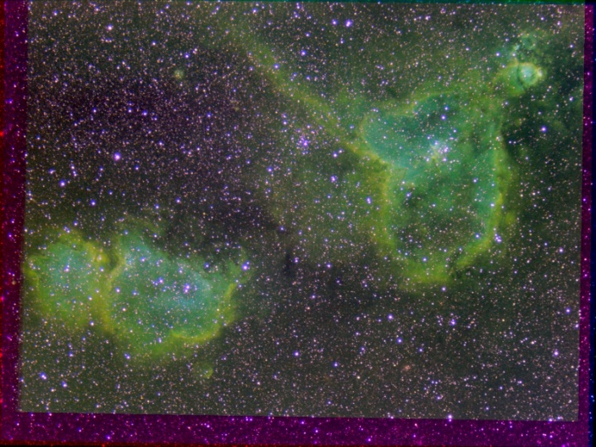

IC1805-2X1X-RGB-SHO-Sat130pct-ColBal-HalfSize.jpg

### 2017-Nov-28 (Nov-29 UT): Neptune, Uranus, Satellites and the Moon

Last Updated 12/3/2017

**NEPTUNE**

Despite very good seeing (better than predicted), I do not appear to have captured the birhgt equatorial storm. It seems I really do need more aperture. On the good side, I do seem to have a very clearly resolved limb. Also, since the NIR images and CLR images were taken with a linear gamma, it should be straightforward to do photometry. I should have both NIR and CLR photometry for Triton, but only NIR photometry for Neptune since the CLR channel is saturated.

|  |  |  |  |
| --- | --- | --- | --- |
|  |  |  |  |
| 2017-11-29-0227\_2-Neptune\_685NIR\_Gam50-Waveletes2x5+3x10+4x5.png | 2017-11-29-0227\_2-Neptune\_685NIR\_Gam50-Waveletes2x10+3x10-Color.bmp | 2017-11-29-0312\_2-Neptune\_550CLR\_Gam50-Stack114-Wavelets3x10+4x10-Str0to128-Crop.jpg | 2017-11-29-0230\_4-Neptune\_685NIR\_Gam50-Stack600-Wavelets3x5+4x5+Wavelets1x15+2x10-Str0to32-Crop.jpg |

**URANUS**

|  |  |  |  |
| --- | --- | --- | --- |
|  |  |  |  |
| 2017-11-29-0426\_6-Uranus\_685NIR\_Gam50-Wavelets3x10+4x15+5x10.png | 2017-11-29-0426\_6-Uranus\_685NIR\_Gam50-Wavelets3x10+4x15+5x10-Color.bmp | 2017-11-29-0356\_8-EtaPis\_685NIR-Stack200-Wavelets1x20-Crop.jpg | 2017-11-29-0356\_8-EtaPis\_685NIR-Stack200-Wavelets1x20-Crop-Gam50pct.jpg |

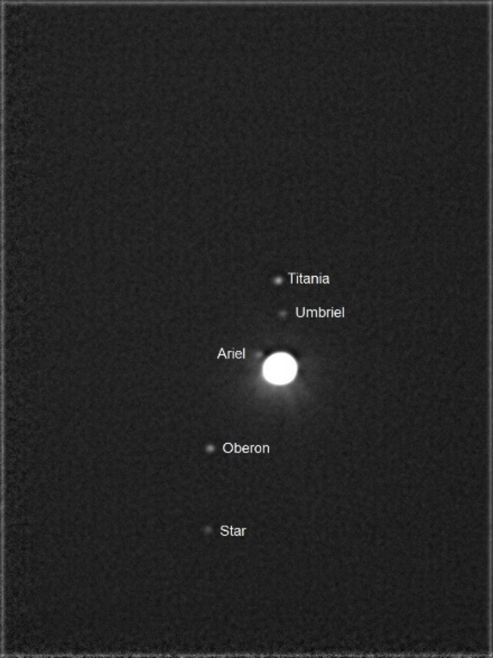

2017-11-29-0406\_9-Uranus\_550OPN\_Gam100-Stack72-Wavelets5x10+6x10-Str0to128-Annotated.jpg

**MOON**

|  |  |
| --- | --- |
|  |  |
| COPERNICUS  2017-11-29-0330\_4-Moon\_685NIR-Stack400-Wavelets1x20+2x10-HalfSize.jpg | TOBIAS MAYER  2017-11-29-0333\_2-Moon\_685NIR-Stack400-Wavelets1x20+2x10-HalfSize.jpg |
|  |  |
| SINUS IRIDUM  2017-11-29-0335\_5-Moon\_685NIR-Stack400-Wavelets1x20+2x10-HalfSize.jpg | MONTES RECTI  2017-11-29-0337\_3-Moon\_685NIR-Stack400-Wavelets1x20+2x10-HalfSize.jpg |

|  |  |
| --- | --- |
|  |  |
| PLATO  2017-11-29-0338\_8-Moon\_685NIR-Stack400-Wavelets1x20+2x10-HalfSize.jpg | EUCLIDES (near LETRONNE)  2017-11-29-0342\_3-Moon\_685NIR-Stack200-Wavelets1x20+2x10-HalfSize.jpg |
|  |  |
| HIPPALUS & AGATHARCHIDES  2017-11-29-0344\_5-Moon\_685NIR-Stack200-Wavelets1x20+2x10-HalfSize.jpg |  |

BTW: Google Moon is great! <https://www.google.com/moon/>

**Data Disposition:** Raw data is zipped on the Astronomy laptop and ready to be transferred to the 2TB archive drive. The processed data resides on the ASTROTHUMB3 thumbdrive (128GB) under the projects subdirectory structure.

## December

### 2017-Nov-30 (Dec-01 UT): M31 807NIR

Last Updated 11/13/2017

I very much need to get a good 807NIR flat field for calibration. The image below (as of 12/1/2017) uses an 501OIII flat field that had worked well for other narrow band filters in the visible, but clearly does not work in the NIR.

|  |
| --- |
|  |
| M31-20171201UT-807NIR-sum0h35m-Flattened-LogLog-HalfSize.jpg |

Now would be a good time to switch filter configuration on the ST2000 from:

* 807NIR, 486HIB, 742NIR, 656HIA, 672SII to
* 807NIR, **889CH4**, 742NIR, 656HIA, 685NIR

**Data Disposition:** Raw data is zipped on laptop ready to move to 2TB archive drive. Processed data is on Astronomy3 thumb drive.

### 2017-Dec-04 (Dec-05 UT): M31 807NIR

Last Updated 12/05/2017

Turns out I didn’t need to get a flat for 807NIR. The poor results from 12/01 were really do to incredibly large cloud brightness signature amplifying what otherwise would have been unnoticeable flat field artifacts. 501OIII flat field worked well tonight when the sky was truly clear (transparency 4-5).

|  |
| --- |
|  |
| M31-20171205UT-807NIR-sum2h00m-Flattened-LogLog-HalfSize.jpg |

**Data Disposition:** Raw data is zipped on laptop ready to move to 2TB archive drive. Processed data is on Astronomy3 thumb drive.

### 2017-Dec-09 (Dec-10 UT): M33 656HIA

Last Updated 12/10/2017

This was pretty much a test run. I converted my configuration to image through the C8 with the ST2000. The goal was to begin high resolution imaging of M33, first with narrow band filters. The equipment configuration change and tracking calibration went smoothly. Tracking calibration was done with the 550OPN filter so there was plenty of signal for the tracking star at ~1.0 sec exposure time.

However, once I moved to 656HIA, the signal level was low, even for 7 second exposures. This was way too long for effective tracking and the X (RA) axis oscillated by 10 pixels peak-to-peak. I ended up doing 30 second unguided individual images.

An additional item is that I focused with the 550OPN position. There is an offset (possibly not parfocal as the 550CLR filter would have been?) with the 656HIA filter. Thus, next time I do need to focus in the filter I’ll be imaging with. This may provide a slight improvement in the tracking star image as well.

Finally, in more sensitive parts of the spectrum, e.g., 501OIII, the tracking star was also brighter. I have a few more nights forecast to be clear to improve skills on this target and in this configuration.

|  |
| --- |
|  |
| M33-20171210UT-656HIA-sum1h00m47s-Log-Smth-HalfSize.jpg |

Many HII regions show up very clearly, despite poor tracking and poor focus. In addition, since I have to do unguided images, better polar alignment would reduce the overall drift. This would improve the overall coverage and reduce the streaking artifacts due to residual dark signal.

### 2017-Dec-10 (Dec-11 UT): M33 656HIA

Last Updated 12/18/2017

TBD

|  |
| --- |
|  |
| M33-20171211UT-656HIA-sum1h04m30s-wNGC604-Flattened-LogLog-Smooth-HalfSize.jpg |

### 2017-Dec-12 (Dec-13 UT): M33 501OIII

Last Updated 12/19/2017

TBD

|  |
| --- |
|  |
| M33-20171213UT-501OIII-sum1h08m45s-AvgFlat-wNGC604-Flattened-LogLog-HalfSize.jpg |

### 2017-Dec-14 (Dec-15 UT): M33 672SII

Last Updated 12/19/2017

Heavy frost on the corrector plate made this observing run essentially unusable. However, some stars are visible and NGC604 is detectable. A new observing run needs to be done for 672SII and should not be combined with this data set.

|  |
| --- |
|  |
| M33-20171215UT-672SII-sum0h58m30s-Smooth-LogLog-HalfSize.jpg |

### 2017-Dec-19 (Dec-20 UT): M33 672SII

Last Updated 12/19/2017

There were some clouds late during during the exposure.

|  |
| --- |
|  |
| M33-20171220UT-672SII-sum0h37m00s-wNGC604-Flattened-LogLog-HalfSize.jpg |

### Winter 2018 Planning

Last Updated 12/20/2017

* Observations – January 1 first visibility times; Dark around 5:30pm
  + Imaging – wide field
    - 10:00pm – M45 Pleiades
    - 10:30pm – NGC1499 California Nebula
    - 12:00am – Simeis 147
  + Video – 4500mm
    - 9:00pm – M42 – more CRGB with wider coverage. Maybe try narrow band…
  + Imaging – 1260mm
    - 6:00pm – M33 – **1260mm** (need **all narrow band images**)
    - 9:00pm – M42 – **1260mm** (NII)
    - 10:00pm – M1 Crab Nebula – **1260mm** (need **all narrow band images**)
* Analysis
  + M31 Multispectral Analysis *ala* M33, M81, M101 etc.
  + Solar Eclipse Movies, ratio analysis, etc.
  + Questions for OPT:
    - NII filter
    - GoTo Mounts
    - Motorized Focuser
    - Custom Filters

## Planets

### Neptune

This year I tried to resolve Neptune sufficiently to see a major NIR-bright storm. While it doesn’t seem like I succeeded there, I did have three imaging runs on Neptune. All the runs included linear gamma settings (gamma=50) on the ASI120MM and should be amenable to photometry. During Registax stacking, some of images were stretched to take up more of the dynamic range of the image file. Some image files were saved as PNG (16-bit) files and some were saved as BMP (8-bit) files.

An experiment with Registax and MaximDL shows that if the original data are PNG files – as some long exposures are from SharpCap – then the files are 8 bit files, just as if they were AVI frames or BMP files. When they are stacked in Registax and saved as PNG files, they are *averaged* then saved as 16bit (x3 for RGB=48bit). In this process they are rescaled with a multiplicative factor of 256 (28).

## References

Buratti, B. J., Bauer, J. M., Hicks, M. D., Hillier, J. K., Verbiscer, A., Hammel, H., . . . Foust, J. (2011). Photometry of Triton 1992-2004: Surface volatile transport and discovery of a remarkable opposition surge. *Icarus, 212*, 835-846.

Danehkar, A., Karovska, M., Maksym, W. P., & Montez, R., Jr. (2017). Mapping Excitation in the Inner Regions of the Planetary Nebula NGC 5189 using HST WFC3 Imaging. *ArXiv e-prints, 1711*. Retrieved from <http://adsabs.harvard.edu/abs/2017arXiv171111111D>

Mallama, A., Krobusek, B., & Pavlov, H. (2017). Comprehensive wide-band magnitudes and albedos for the planets, with applications to exo-planets and Planet Nine. *Icarus, 282*, 19-33.

Parker, R. A. R. (1964). Physical Conditions in the Cygnus Loop and Some Other Possible Supernova Remnants. *The Astrophysical Journal, 139*, 493.

Pascu, D., Storrs, A. D., Wells, E. N., Hershey, J. L., Rohde, J. R., Seidelmann, P. K., & Currie, D. G. (2006). HST BVI photometry of Triton and Proteus. *Icarus, 185*, 487-491.